Closing the digital divide for First Nations families and children

Joint Indigenous Digital Inclusion Plan submission by Good Things Foundation Australia and Save the Children
November 2021

Table of Contents
Acknowledgements of Country 2
Introduction 3
The digital divide for First Nations families and children 4
Digital inclusion is a human rights issue 6
Impacts of COVID-19 on digital inclusion 8
Affordable access 8
Digital skills and confidence 9
Current work 10
inDigiMOB 10
Be Connected 11
eSafety’s co-created resources 12
Save the Children program 12
Recommendations 13
About Good Things Foundation Australia 15
About Save the Children 15
Contact 16

Acknowledgements of Country
Good Things Foundation Australia acknowledges that we meet on the land of the Gadigal people of the Eora Nation. We pay our respects to elders - past, present and future.
Save the Children Australia acknowledges Aboriginal and Torres Strait Islander peoples as the traditional owners and custodians of the land on which we work. We pay our respect to their Elders past and present.

Introduction
It is important that everyone can access the information and services they need. In today’s digital world, this means having the connectivity, ability and affordability to be safe and confident online.
The COVID-19 lockdown restrictions across Australia have changed the way we live and work, and highlighted digital inclusion as an issue for the Australian government and all states and territories. As the world increasingly moves online, some Australians are more at risk of being left behind in their ability to access information, services, contribute to Australia’s digital economy, and stay connected to others.
First Nations families and children, especially from low-income households and remote communities, are vulnerable to the risks of being digitally excluded. Not being digitally included from an early age can have long-term impacts, being a barrier in accessing further education and employment.
Equal digital inclusion of First Nations peoples has recently been recognised as essential to Closing the Gap, being identified as one of the 17 national targets to ensure equal access to information and services in the National Closing the Gap Agreement. Further, digital inclusion has the potential to support the fulfilment of fundamental human rights.
We welcome the opportunity to provide feedback on the Indigenous Digital Inclusion Plan discussion paper, an important step in recognising the need for First Nations people to be equally digitally included that many have been calling for years now. We believe that building digitally resilient families will assist in creating more connected communities.
Governments at all levels should support and enable First Nations people, communities and community organisations to lead the development and implementation of solutions to improve digital inclusion with targeted, specific and additional investment for programs and solutions.
Good Things Foundation Australia and Save the Children Australia thank the National Indigenous Australians Agency for the opportunity to make this submission, especially in light of the current importance of digital inclusion due to COVID-19 restrictions.
In making this submission, we recognise that although Good Things Foundation Australia and Save the Children Australia have expertise in digital inclusion and delivering programs for children, we are not First Nations led organisations. It is critical that First Nations communities, leaders and organisations have priority in being heard on the issue of closing the digital divide through the Indigenous Digital Inclusion Plan.

The digital divide for First Nations families and children
Across Australia, the digital divide impacts many people and communities. While research indicates that the pandemic has seen the rate of people completely offline fall, one in four people are still digitally excluded. People who are on low incomes, have lower levels of education, have a disability, are older or have a mobile-only connection, First Nations people and people living in regional/rural Australia are particularly at risk of being digitally excluded. These factors can overlap to create deeper levels of digital exclusion. As the Indigenous Digital Inclusion Plan Discussion Paper outlines, three intersecting elements influence a person’s ability to cross the digital divide: access, affordability and ability.
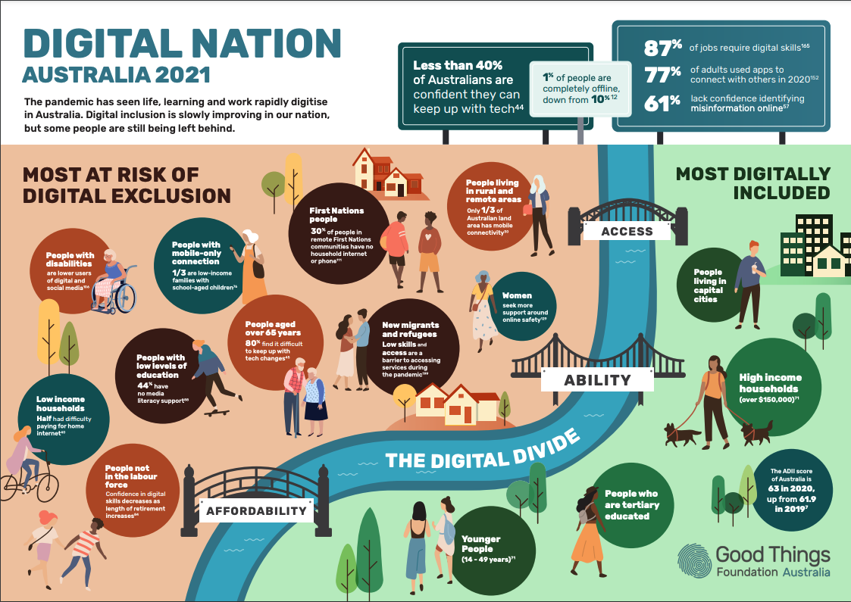
Good Things Foundation’s Digital Nation Australia 2021 report brings together the latest research from government, corporates and academia.
Between 2019 and 2020, there was no improvement in the overall Australian Digital Inclusion Index (ADII) score for First Nations peoples when considering these factors. First Nations peoples living in urban and regional areas were 7.9 points below the national average ADII score for digital inclusion.
For low-income families with school aged children, affordability is the most significant barrier to digital inclusion. Given First Nations households are more likely to be living on low incomes than non-First Nations households, this is a significant barrier to be resolved in closing the digital divide. The 2020 ADII saw low income families with school children spending about five times more of their household income on data access compared to families in higher income quintiles and compared to national spending. This was largely due to low-income families being more dependent on mobile-only access, with one third being mobile-only users. These families scored 29.8 points lower in the ADII for affordability compared to other families with school-aged children, and the affordability divide has not been closing over time.
This opens up the significant risk of First Nations families and children experiencing data poverty, which may have flow-on effects to digital capabilities.
In a recent survey of Good Things Foundation’s network of community organisations, 68% of regional Network Partners reported that there were people aged 18-50 years in their community who are asking for support with access to devices, data and digital skills. This compares to metropolitan based network partners of whom only 51% identified this need. So, there also appears to be the intersection in location of a household and their experience of data poverty and need for digital skills support.
Unfortunately, updated figures for rates of digital inclusion for First Nations people were not available in the 2021 ADII due to low sample sizes. Recognising the challenge in including First Nations people in the broad ADII research, Telstra has launched the ‘Mapping the digital gap’ research project to track digital inclusion changes over four years for several First Nations communities. This will sit alongside the ADII and extend knowledge of the depth of the digital divide for First Nations people, as well as how to best address this issue. While this new research has now been commissioned, a national approach to understanding the digital inclusion landscape for First Nations families and children is not readily available. Introducing and funding national, multi-year, culturally appropriate research would be beneficial to measure rates of digital exclusion and the impact of initiatives to improve it for First Nations families across the country.

Digital inclusion is a human rights issue
Addressing digital inclusion is critical in addressing the realisation of fundamental human rights issues. More than a decade ago, the then Special Rapporteur on the promotion and protection of the right to freedom of opinion and expression stated that: “Without concrete policies and plans of action, the Internet will become a technological tool that is accessible only to a certain elite while perpetrating the “digital divide”. Human rights treaties to which Australia is a party to, including the Convention on the Rights of the Child (CRC), Convention on the Elimination of All Forms of Discrimination (CERD), and the International Covenant on Economic, Social and Cultural Rights (ICESCR), as well as the United Nations Declaration on the Rights of Indigenous Peoples (CERD), and state and territory human rights acts, are all of relevance in developing the Indigenous Digital Inclusion Plan.
The right to non-discrimination as expressed in Article 2 of the CRC, Article 2 of CERD and Article 2 of ICESCR, provides that state parties shall guarantee rights without discrimination. That includes, as contained in CERD, taking special and concrete measures to ensure the adequate development and protection to guarantee the full and equal enjoyment of human rights and fundamental freedoms. Laws and policies must ensure that First Nations peoples are not subject to discriminatory exclusion from the benefits of emerging digital inclusion technologies.
The Australian Human Rights Commission has recently observed that as technology evolves, people who experience multiple forms of disadvantage, such as First Nations Australians with disability, may be at greater risk of the harmful impacts of those technologies. This can lead to experiences of discrimination and exclusion being exacerbated, a risk that can be minimised for First Nations children and families through full digital inclusion.
The right to education is contained in Article 28 of the CRC and Article 13 of ICESCR and highlights the importance of ensuring that education is accessible in a non-discriminatory manner. The impact of COVID-19 and use of home schooling has further amplified the importance of access to technology relevant for education for children. In considering the right to education it is also important that strength based approaches by First Nations peoples are considered in realising those rights.
Other rights involved in considering digital inclusion include the right to health, right to freedom of expression, right to access information, best interests of the child, among others. Recent years have also seen an increasing acknowledgment of the interconnection between the digital environment, realisation of fundamental rights, and the impact upon Indigenous peoples. For example, the digital gap for Australia’s First Nations peoples was highlighted by the United Nations Special Rapporteur on contemporary forms of racism, racial discrimination, xenophobia and related intolerance in a report in June 2020. Additionally, broader concerns with respect to Indigenous peoples and digital inclusion was noted in General comment No. 25 on children’s rights in relation to the digital environment released in March this year. Other forums, such as the United Nations Third Cycle Universal Periodic Review (UPR), have highlighted the need for Australia to address entrenched inequalities and overrepresentation across all low socioeconomic indicators, which would include digital inclusion.
Additionally, the Indigenous Digital Inclusion Plan provides an opportunity for the National Indigenous Australians Agency to consider how to realise the right to self-determination as expressed in UNDRIP. Full, effective and meaningful participation of First Nations peoples cannot be realised without addressing the digital divide. As civil society organisations expressed through the UPR process, there are substantial gaps in Australia for First Nations peoples in upholding the right to self-determination across a wide range of policies and laws. Addressing the digital divide must also have in mind the protection and promotion of Article 3 and 4 of UNDRIP in particular.
It noted that the Discussion Paper does not make any reference to the protection and promotion of human rights, let alone refer to the increasing discussion on the role of digital inclusion from UN human rights bodies, procedures or special mandate holders. It is important that the Indigenous Digital Inclusion Plan adopts a rights based approach towards inclusion, including shaping how emerging digital technologies are utilised and informing the approach of the private sector.

Impacts of COVID-19 on digital inclusion
The digital divide has had real world impacts on people’s everyday lives during the pandemic. Lower levels of affordable access and online participation means that First Nations families in Australia are more likely to experience exclusion from the digital economy. Due to the rapid digitisation of essential services, information and education, the need for affordable internet connectivity and the skills to use it is more evident than ever.
The COVID-19 pandemic has rapidly digitised education at all levels, meaning people at higher risk of digital exclusion face additional barriers to participate equally. Low income families with school aged children lack access to digital devices, pay more for their data compared to other families, and have lower levels of digital ability. Research from The Smith Family shows that before the pandemic, in Australia’s most disadvantaged communities, only 67.8% of school aged children (5-14 years of age) accessed the internet at home, compared with 90.5% of students from the most advantaged communities. When we add to that First Nations students having significantly lower rates of home internet access than the public school student average, the potential disparity in access to education becomes clearer. Research has already identified that very few families from remote indigenous communities were able to readily access services like MyGov and education or work from home during COVID-19 restrictions due to lower levels of digital inclusion.

Affordable access
The digital divide for First Nations families is exacerbated by a lack of affordable in-home internet access and appropriate devices.
An estimated 30% of First Nations people living in remote indigenous communities do not have household access to internet or telephone services, despite improvements in infrastructure, such as the implementation of the National Broadband Network. This indicates that factors beyond physical access may be resulting in this divide. For First Nations school children there is a particular disparity in access, with research showing that 21% do not have internet access at home compared to 5% for all public school students.
Affordability of the internet and devices has been a persistent issue for First Nations communities. Research has identified that affordability is one of the main factors for reduced rates of household internet access in remote indigenous communities in particular. One of the factors impacting affordability is the higher rate of mobile-only users with prepaid connectivity at 35.0% for First Nations people compared to the national average of 19.9%. Mobile-only use has often had a higher cost per unit than fixed internet connections such as home wifi from broadband internet.
Good Things Foundation’s experience shows that while temporary loan devices with free data can help to support affordable access to the internet in homes in the short-term, it is not a long-term solution. In 2020, 75% of Good Things Foundation’s network of community organisations stated that some or all of their learners did not have adequate access to devices or data at home. In response, through the Be Connected program Good Things Foundation developed grant funding for this network to deliver loan devices with data to isolated older learners, which was extremely well received. However, even after this intervention, when the same question was asked of the network in August 2021, 74% of respondents still stated that learners in their community lacked access to appropriate data and devices. This illustrates how, particularly for low income families, free or low cost internet access and appropriate devices to access it are essential.

Digital skills and confidence
The ADII 2020 shows that First Nations peoples are more likely to have lower levels of digital ability with an ability score 9.2 points below the national average. Digital ability incorporates attitudes towards technology and motivation, confidence and essential digital skills including safety, and digital media literacy.
49% of First Nations respondents in a recent media literacy study showed a low level of interest in new technology, a rate 12% higher than that of non-First Nations people. Further, First Nations Australians were identified in this study, alongside other groups, as being at higher risk of having low media literacy and not accessing a broad range of media channels. Research by the eSafety Commissioner has also identified that improving digital literacy in a culturally appropriate setting, particularly on topics such as privacy settings, can improve support for First Nations women experiencing technology-facilitated abuse.
Factors that Good Things Foundation has found to impact the delivery of digital literacy programs include low levels of English literacy, lack of access to devices and data at home, fear of scams and online safety concerns, and restrictions on accessing in-person support due to COVID-19. A major strategy to overcome these barriers is the implementation of funded, community-led, locally delivered but nationally coordinated programs which empower digital mentors to take action to improve digital literacy in ways that best meet their community’s needs.
More tailored, community-led digital ability programs are needed. These should be co-designed with First Nations families with children, to help those struggling with digital skills and access to not get left behind in our digital world.

Current work
A number of initiatives are currently underway in Australia that seek to close the digital divide. There is opportunity and scope to build on these existing programs or share knowledge from their implementation to inform the Indigenous Digital Inclusion Plan and initiatives implemented stemming from it to better support First Nations families and children. Digital inclusion initiatives led and designed by First Nations communities can bring significant benefits, and this will require additional investment by Government and funders.

inDigiMOB
The inDigiMOB project supports remote Indigenous communities in digital inclusion activities across the Northern Territory and is a collaboration by First Nations Media Australia and Telstra. The most influential aspect of the project is the specific resources, presented in a variety of different mediums, to suit the needs of individual communities to become more digitally included. The inDigiMOB project has been successful for the past four years, and recently extended to South and Western Australia. It has significant potential to upscale digital skills through local Councils, with ongoing support to provide unique solutions and training to address barriers Aboriginal and Torres Strait Islander people living in regional and remote communities face getting online.

Be Connected
Be Connected is an Australian Government initiative supporting and enabling older Australians (over 50’s) to develop digital skills and confidence online. Good Things Foundation Australia manages, upskills and funds the national network of 3500 community organisations and their digital mentors to deliver locally tailored and trusted programs. eSafety Commission creates high quality and trusted online learning content. The Department of Social Services provides governance and oversight of the program.
To date, the program has reached one million Australians and seen 15,000 people become Digital Mentors, who are able to further support their communities to gain confidence online.
- Read the Be Connected Evaluation
Monthly survey responses from the organisations in the network indicate that 3.62% of learners supported across the country identify as Indigenous. Of the 3,500 organisations registered as part of Be Connected, 1,718 have included Aboriginal and Torres Strait Islander people as being part of their 'target audience'.
- Read how Kinchella Boys Home Aboriginal Corporation participated in Be Connected
In 2021, the Be Connected grant program was amended to include reduced learner KPI targets for ‘Supporting older Australians with significant barriers to learning’. One of the demographic groups eligible under these reduced targets were Indigenous Australians, recognising the need for First Nations communities to have access to more tailored funded supports.
However, requests have been received from community organisations in the network working with First Nations community members to lower the eligibility age of the program to include under 50’s. Good Things Foundation has also heard feedback from our network that the Be Connected learning resources also need to be adapted to be culturally appropriate to better resonate with First Nations communities. This requires a specifically funded, co-design process to be undertaken. Be Connected is a program with the scope to benefit more Australians, including First Nations families, to gain essential digital skills if expanded to include adults aged under 50 and with targeted additional funding support.

eSafety’s co-created resources
The Office of the eSafety Commissioner has produced some resources to help First Nations communities and families learn more about online safety. This includes the Your Journey Online app and the Be Deadly Online resources, targeting online safety skills for First Nations children and young people.

Save the Children program
The First Nations families that Save the Children works with across all states and territories have varied and diverse experiences with digital technology. One common theme across regions however is limited access to adequate household technology. While the majority of families may have a mobile phone, they might not have access to WIFI given the significant costs. Additionally, they may not have a working laptop for the children to use. During COVID-19 lockdowns this was a major issue as children were unable to access online education materials. Parents then had to book in to obtain paperwork from the school which created yet another access barrier. This led to bullying and segregation for some of the children whom Save the Children work with.
Due to complex challenges, the families within Save the Children’s programs often do not see technology as relevant or essential as day-to-day their focus is on simply surviving, many are facing significant family trauma, domestic violence and pay cheques will generally go towards food and bills, with little left over. Phone handsets and phone numbers often change hands rapidly as resources are shared according to need although this creates challenges in families being contactable by education, health and other services. In South Australia, Save the Children worked with a family whose infant missed vital medical tests, because health services could not connect with the parents as all relevant phone numbers documented on birth forms had changed hands or had been discontinued. In regard to children’s safety, the cost of current technology or essential technology for school, families may opt for a cheaper alternative which does not have the same safety features as, for example, a higher end smartphone. This reduces their ability to ensure that they are digitally safe and increases the chance of bullying and racism. Children are often not able to receive support from their parents, who did not have access to technology growing up and are already behind.
These challenges are often exacerbated for those living in regional and remote areas, which can create safety, health and child protection issues. For example, in regional New South Wales Save the Children worked closely with a single mother experiencing severe mental health and drug use difficulties, who is isolated on a farmhouse 30km from a major regional centre. The mother’s mental health is very unstable. Limited access to data and mobile coverage has placed both the mother and her son at risk daily, as she has breakdowns and episodes, and she has limited ability to call for help.
Save the Children acknowledges that there is often a tension between the program delivery of digital services, particularly mental health support in regional areas, and the advocacy demands for in-person services. In our experience, in working with First Nations communities, children regularly look to those whom they already trust; particularly when there are language barriers. Ensuring that there is regular contact and support to enable appointments whether virtual or in-person is critical. Advancing digital inclusion and broadening options needs to ensure that programs on the ground are supported adequately to help link First Nations children, young people and families into services. This should not be secondary to another service but should be funded as an important link in service provision in its own right.

Recommendations
Improving digital inclusion will help First Nations families and children to access education, information and services, contribute to Australia’s digital economy, and stay connected to loved ones.
While there are successful national programs funded to support the broad population of older Australians to improve their digital skills, there is no nationally funded program to support or understand digital inclusion for First Nations families. Solutions to closing the digital divide for First Nations families will require an approach that ensures everyone has affordable access to the internet and appropriate devices, as well as the skills, motivation and confidence to use it safely.
Digital inclusion programs that are designed and led by First Nations people and organisations are needed at a national level to support First Nations families and children to be digitally included, and stay connected in our growing digital world. This will take additional funding commitments to deliver the tailored, culturally appropriate solutions.
To support all First Nations families and children to become digitally resilient for the future, Good Things Foundation Australia and Save the Children Australia recommend:
- Co-design with First Nations leaders and communities a culturally appropriate and specific national digital inclusion strategy. The government's national Indigenous Digital Inclusion Plan needs to be co-designed with First Nations communities, including people in regional and remote communities, through methodologies that engage First Nations families and children experiencing digital exclusion and the community organisations that support them.
- Adopt a rights based approach towards digital inclusion, including special measures which promote the right to non-discrimination, right to education, right to self-determination and other fundamental rights. This includes ensuring full and meaningful consultation with First Nations peoples on all matters affecting them with respect to the implementation of the Indigenous Digital Inclusion Plan.
- Provide funding and support for national community education programs led by First Nations people, for First Nations people, to ensure all First Nations families and children have the essential digital skills to be school and work-ready in the new economy, can access digital health initiatives, and stay connected to communities safely and confidently.
- Ensure every First Nations family in Australia has affordable access to the internet. Implement the recommendations of organisations such as ACCAN to support low income households to better afford a reliable internet connection, and the provision of appropriate digital devices.
- Support research on the digital divide for First Nations families and children, to continue efforts identifying and addressing the barriers, effects and solutions for digital exclusion in these communities.

About Good Things Foundation Australia
Good Things Foundation Australia is a social change charity, helping people to improve their lives through digital. We work with partners in thousands of communities across Australia and the UK.
In Australia, we have built and manage the Australian Government funded Be Connected Network of 3,500 community partners and deliver a small grants program to support people over 50 to learn essential digital skills. We coordinate the annual digital inclusion campaign Get Online Week, which last year supported 23,500 people to improve their digital skills. With the support of the Australian Digital Health Agency and our network of community organisations, we assisted adults of all ages to improve their digital health literacy through our Health My Way program.
Good Things Foundation has run digital inclusion projects in the UK for over ten years and worked in Australia since 2017.
Learn more about our work:
- Information about our projects
- Our research and publications

About Save the Children
Save the Children is a leading independent international organisation for children and child rights. Our vision is a world in which every child attains the right to survival, protection, development and participation. Our purpose is to inspire breakthroughs in the way the world treats children and to achieve immediate and lasting change in their lives. We work towards this vision in Australia and more than 120 countries across the globe.
Save the Children has worked alongside Aboriginal and Torres Strait Islander communities for over 65 years. We recognise the importance of Aboriginal and Torres Strait Islander leadership and ownership in shaping culturally safe ways of working that reflect local needs and priorities. Over half of our direct programming is in Australia, supporting around 30,000 children and adults across 200 communities and locations in every State and the Northern Territory. This includes programs spanning early childhood development, family support services, school education engagement initiatives, and public health-informed youth justice programming.

Contact
Liz Jones
Director Partnerships & Growth, Good Things Foundation Australia
P: 02 9521 9292
E: liz.jones@goodthingsfoundation.org
www.goodthingsfoundation.org

Simon Henderson
Head of Policy, Save the Children Australia
P: 02 8202 9136
E: simon.henderson@savethechildren.org.au
www.savethechildren.org.au

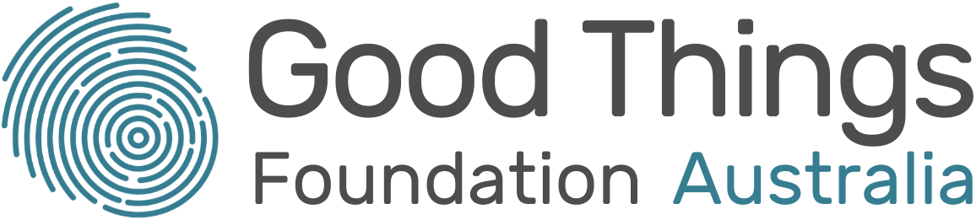

Australian Government, Closing the Gap in Partnership (2020), National Agreement on Closing the Gap
Thomas, J., Barraket, J., Parkinson, S., Wilson, C., Holcombe-James, I., Kennedy, J., Mannell, K., Brydon, A. (2021). Australian Digital Inclusion Index: 2021. Melbourne: RMIT, Swinburne University of Technology, and Telstra, p. 5
Thomas, J, Barraket, J, Wilson, CK, Holcombe-James, I, Kennedy, J, Rennie, E, Ewing, S, MacDonald, T, (2020), Measuring Australia’s Digital Divide: The Australian Digital Inclusion Index 2020, RMIT and Swinburne University of Technology, Melbourne, for Telstra, p. 15
Ibid, p. 19
Ibid.
Ogle, G (2017) Submission on the Productivity Commission Telecommunications Universal Service Obligation Draft Report, SACOSS, Adelaide
Osborne K, Baum F & Brown L (2013). What works? A review of actions addressing the social and economic determinants of Indigenous health, Canberra: AIHW, viewed 5 August 2021, cited in AIHW, Indigenous income and finance accessed 5 Nov 2021
Thomas et al. (2020), p. 25
Ogle, G & Musolino, V (2016) Connectivity Costs: Telecommunications Affordability for Low Income Australians, SACOSS and ACCAN, Sydney
Thomas et al. (2020), p. 25
Frank La Rue, Report of the Special Rapporteur on the promotion and protection of the right to freedom of opinion and expression, A/HRC/17/27, 16 May 2011.
Human Rights Act 2004 (ACT), Charter of Human Rights and Responsibilities 2006 (Victoria) and the Human Rights Act 2019 (Queensland).
Racial discrimination and emerging digital technologies: a human rights analysis, Report of the Special Rapporteur on contemporary forms of racism, racial discrimination, xenophobia and related intolerance, A/HRC/44/57, 18 June 2020.
PwC Indigenous Consulting, submission to the IP cited in https://tech.humanrights.gov.au/sites/default/files/2019-12/TechRights2019_DiscussionPaper.pdf
PwC Indigenous Consulting, submission to the IP cited in https://tech.humanrights.gov.au/sites/default/files/2019-12/TechRights2019_DiscussionPaper.pdf
Ibid.
United Nations Committee on the Rights of the Child, General comment No. 25 (2021) on children’s rights in relation to the digital environment, CRC/C/CG/25, 2 March 2021.
See for example the recommendation from New Zealand: “Continue its work to address the ongoing reports of entrenched inequalities and overrepresentation across all low socioeconomic indicators that disproportionally affect Aboriginal and Torres Strait Islander peoples, especially in the areas of health and well-being, education and justice”. This was accepted by the Australian government. See Report of the Working Group on Universal Periodic Review, A/HRC/47/8, 24 March 2021, and Human Rights Council, Report of the Working Group on Universal Periodic Review, A/HRC/17/8/Add.1, 2 June 2021.
Thomas et al. (2020), p. 24
The Smith Family (2013) Sport, Culture and the Internet: Are Australian Children Participating? The Smith Family Research Report, p. 5
Preston, B (2020) Digital Inclusion for all Public School Students, Barbara Preston Research
Thomas et al, (2020), p. 19
Featherstone, D (2020) Remote Indigenous Communications Review. Telecommunications Programs and Current Needs for Remote Indigenous Communities, ACCAN, p. 7, 9
Preston, B (2020) Digital Inclusion for all Public School Students, Barbara Preston Research, p. 5
Featherstone, D (2020) p. 9
Thomas et al (2020), p. 19
Thomas et al (2020), p. 21
Notley, T Chambers, S Park, S Dezuanni, M (2021) Adult Media Literacy in Australia: Attitudes, Experiences and Needs, WSU, QUT and University of Canberra, p. 68
Ibid. p 10
eSafety Commissioner (2019) Online Safety for Aboriginal and Torres Strait Islander Women Living in Urban Areas, p. 58

