Good Things Foundation Australia

Submission & Recommendations

Closing the digital divide for First Nations communities

Indigenous Digital Inclusion Plan Submission by Good Things Foundation Australia
November 2021

Table of Contents
Acknowledgement of Country 2
Introduction 3
The Digital Divide for First Nations People 3
Affordable Access 5
Ability and safety 6
Current work 7
inDigiMOB 7
Be Connected 7
Health My Way 10
eSafety’s co-created resources 10
Mapping the digital gap 11
Recommendations 11
About Good Things Foundation Australia 13
Contact 13

Acknowledgement of Country
Good Things Foundation Australia acknowledges that we work on the land of the Gadigal people of the Eora Nation. We pay our respects to elders - past, present and future.

Introduction
It is important that everyone can access the information and services they need. In today’s digital world, this means having the connectivity, ability and affordability to be safe and confident online.
The COVID-19 lockdown restrictions across Australia have changed the way we live and work, and highlighted digital inclusion as an issue for all states and territories. As the world increasingly moves online, some Australians are more at risk of being left behind in their ability to access information, services, contribute to Australia’s digital economy, and stay connected to others.
We welcome the opportunity to provide feedback on the Indigenous Digital Inclusion Plan discussion paper, an important step in recognising the need for First Nations people to be equally digitally included that many have been calling for years now. There is significant ground our communities, government, and leaders need to make up to ensure we meet the National Partnership Agreement target of equal digital inclusion for all First Nations Australians by 2023.
We believe that building digitally resilient communities will assist in creating more connected communities. To do this, Governments need to enable First Nations people, communities and community organisations to lead the development and implementation of solutions to improve digital inclusion with targeted, specific and additional investment for programs and solutions.
Good Things Foundation Australia thanks the National Indigenous Australians Agency for the opportunity to make this submission.
In making this submission, we recognise that although Good Things Foundation Australia has expertise in digital inclusion programs, we are not a First Nations led organisation. It is critical that First Nations communities, leaders and organisations lead the development of the Indigenous Digital Inclusion Plan.

The Digital Divide for First Nations People
Across Australia, the digital divide impacts many people and communities. While some evidence indicates that the pandemic has seen the rate of people completely offline fall, one in four people are still digitally excluded.
People who are on low incomes, have lower levels of education, have a disability, are older or have a mobile-only connection, First Nations people and people living in regional/rural Australia are particularly at risk of being digitally excluded.
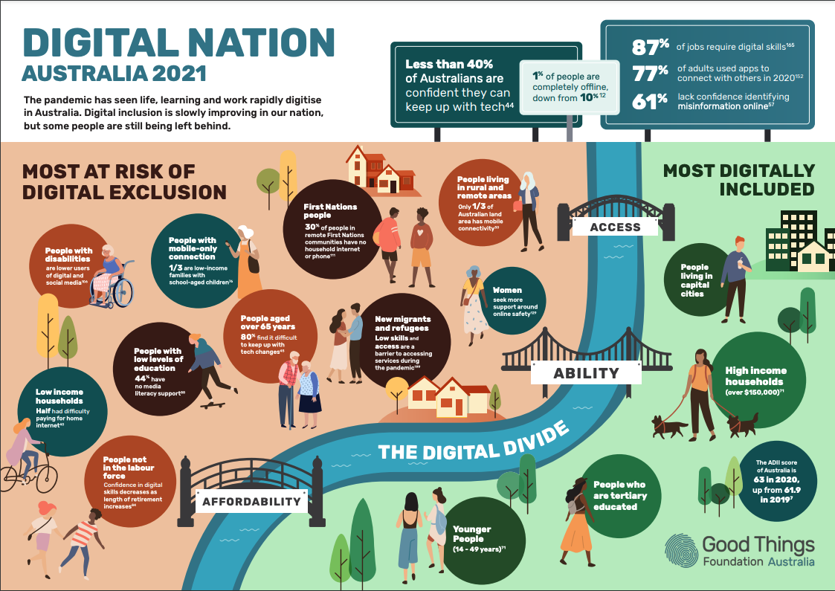
Good Things Foundation’s Digital Nation Australia 2021 report brings together the latest research from government, corporates and academia.
Between 2019 and 2020, there was no improvement in the overall Australian Digital Inclusion Index (ADII) score for First Nations peoples. First Nations peoples living in urban and regional areas were 7.9 points below the national average ADII score for digital inclusion.
Unfortunately, updated figures were not available in the 2021 ADII due to low sample sizes. While some new, targeted research has now been commissioned (see Mapping the digital gap), a national approach to understanding the digital inclusion landscape for First Nations communities is not readily available. Introducing and funding national, multi-year, culturally appropriate research would be beneficial to measure rates of digital exclusion and the impact of initiatives to improve it for First Nations people.
As the Indigenous Digital Inclusion Plan Discussion Paper outlines, three intersecting factors influence a person’s ability to cross the digital divide: access, affordability and ability.
This digital divide has real world impacts on people’s everyday lives.
Lower levels of affordable access and online participation means that First Nations peoples in Australia are more likely to experience exclusion from the digital economy. Due to the rapid digitisation of essential services, information and education moving online, and risks associated with COVID-19 for the First Nations population, the need for affordable internet connectivity and the skills to use it is more evident than ever. For example, very few remote indigenous communities were able to readily access services like MyGov and education or work from home during COVID-19 restrictions due to lower levels of digital inclusion. As the Discussion Paper describes, equal digital inclusion of First Nations peoples has recently been recognised as essential to Closing the Gap, being identified as one of the 17 national targets to ensure equal access to information and services in the National Closing the Gap Agreement.

Affordable Access
The digital divide for First Nations people is exacerbated by a lack of in-home internet access compared to the national average. An estimated 30% of First Nations people living in remote indigenous communities do not have household access to internet or telephone services, even though there has been improvements in infrastructure. For First Nations school children, 21% do not have internet access at home compared to 5% for all public school students, showing a clear disparity.
Affordability is a persistent key issue for First Nations peoples. A relatively high proportion of First Nations peoples are mobile-only users with prepaid connectivity (35.0% versus the national average of 19.9%), often having a higher cost per unit than fixed broadband internet connections. Research shows that affordability is one of the main factors for reduced rates of household internet access in remote indigenous communities.
Our experience shows that while temporary loan devices with free data can help to support affordable access to the internet in homes in the short-term, it is not a long-term solution. In 2020, 75% of our network of community organisations stated that some or all of their learners did not have adequate access to devices or data at home. In response, through the Be Connected program we developed grant funding for this network to deliver loan devices with data to isolated older learners, which was extremely well received. However, even after this intervention, when we asked the same question of our network in August 2021, 74% of respondents still stated that learners in their community lacked access to appropriate data and devices. This illustrates how, particularly in households at higher risk of digital exclusion, free or low cost internet access and appropriate devices to access it are essential. Many organisations have a role to play in tackling this issue, including Government, NBN Co and telcos.
- Read about Grafton Library’s loan device program

Ability and safety
The ADII 2020 shows that First Nations peoples are more likely to have lower levels of digital ability with an ability score 9.2 points below the national average. With digital ability incorporating attitudes towards technology, it is useful to also note that 49% of First Nations respondents in a recent media literacy study had a low level of interest in new technology, a rate 12% higher than that of non-First Nations people.
In our experience, motivating people to learn - as an essential part of improving digital ability - requires tailored, outcome-based approaches meeting a person’s interests and goals. For example, being able to connect with loved ones online when you can’t see them in person.
Additionally, low levels of digital literacy sees First Nations women be more vulnerable to online abuse, less able to identify instances of online abuse, and negatively impacts their ability to take action once online abuse has been identified. Similarly, improving digital literacy in a culturally appropriate setting, particularly on topics such as privacy settings, can improve support for First Nations women experiencing technology-facilitated abuse.
Factors that we have found to impact the delivery of digital literacy programs include low levels of English literacy, lack of access to devices and data at home, fear of scams and online safety concerns, and restrictions on accessing in-person support due to COVID-19. A major strategy to overcome these barriers is the implementation of funded, community-led, locally delivered but nationally coordinated programs which empower digital mentors to take action to improve digital literacy in ways that best meet their communities needs.

Current work
A number of initiatives are currently underway in Australia that seek to close the digital divide. There is opportunity and scope to build on these existing programs or share knowledge from their implementation to inform the Indigenous Digital Inclusion Plan and initiatives implemented stemming from it. This will require additional investment by Government and funders.

inDigiMOB
The inDigiMOB project supports remote Indigenous communities in digital inclusion activities across the Northern Territory, a collaboration by First Nations Media Australia and Telstra. The most influential aspect of the project are the specific resources, presented in a variety of different mediums, to suit the needs of individual communities to become more digitally included. Topics include online banking, Google, online safety, phone/data plans, social media and navigation apps. The program is delivered through local community partners who are supported to become digital mentors.
The successful inDigiMOB project has recently extended to South and Western Australia. It has significant potential to scale up, providing unique solutions and training to address barriers Aboriginal and Torres Strait Islander people living in regional and remote communities face getting online.

Be Connected
Be Connected is an Australian Government initiative supporting and enabling older Australians (over 50’s) to develop digital skills and confidence online. The program is based on partnerships. At Good Things Foundation Australia, we manage, upskill and fund the national network of 3,500 community organisations and their digital mentors to deliver local programs. Program partner eSafety Commission creates high quality and trusted online learning content. The Department of Social Services provides governance and oversight of the overall program.
To date, the program has reached 1 million Australians and seen 15,000 people become Digital Mentors, who are able to further support their communities to gain confidence online.
An evaluation of the Be Connected program showed a positive social return on investment, with $4.01 created for every $1 invested. The evaluation also showed the program increased social connection and community participation, as well as improving learners' online safety and digital skills.
- Read the Be Connected Evaluation
This successful digital skills program is a blended learning approach - using digital tools and tailored, in-person support to motivate and encourage people to improve their digital capability. The digital mentors delivering the support and the local community organisations in the network are trusted members of the community. They know their community best and can adapt the program to suit their needs and situation. These trusted digital mentors are a big reason as to why this program approach works.
Monthly survey responses from the organisations in our network indicate that 3.62% of learners supported across the country identify as Indigenous. Of the 3,500 organisations registered as part of Be Connected, 1,718 have included Aboriginal and Torres Strait Islander people as being part of their 'target audience'.
- Read how Kinchella Boys Home Aboriginal Corporation participated in Be Connected
In 2021, the Be Connected grant program was amended to include reduced learner KPI targets for ‘Supporting older Australians with significant barriers to learning’. One of the demographic groups eligible under these reduced targets were Indigenous Australians, recognising the need for First Nations communities to have access to more tailored funded supports. This change has the goal of encouraging more organisations supporting First Nations communities to apply for funding to support those most in need.
With social distancing measures in place over the past 18 months, many of our network organisations, including libraries, community centres, social groups, and men’s sheds, were unable to provide face-to-face support. This led to an increased risk of older Australians becoming socially isolated. Our dedicated partners found ways to maintain connections with people in their communities by transitioning their delivery of face-to-face workshops to online or remotely delivered programs. In a recent survey, two-thirds of regionally-based network partners were providing digital skills support in August 2021, through face-to-face, telephone and online means, despite COVID restrictions and widespread lockdowns returning. The primary method through which they were delivering did change depending on the state in which the network partner was based, likely reflecting the different levels of COVID restrictions in place at the time across the country.
However, these efforts have shown that no matter the distance or restrictions, it is possible to provide digital support to those often viewed as too hard to reach. Though learning face-to-face is more ideal, if we are going to increase digital inclusion in our country long term and reach people during times of crisis, particularly when people can’t access in person support due to limitations of mobility, transport or distance, this development of a remote delivery approach needs to continue. Lessons from delivering digital skills programs when mentors and learners could not meet in person are now ready to be applied to long term digital inclusion initiatives co-designed and specific to the needs of regional and remote Australians.
- Read Central Coast Community College’s approach to remote delivery
- Read Reinventing Digital Literacy Support in a Crisis report
Beyond that, it is not just older Australians who are struggling to be digitally included. 68% of regional Network Partners reported in a recent survey that there were people aged 18-50 years in their community who are asking for support with access to devices, data and digital skills. This compares to metro based network partners of whom only 51% identified this need.
Requests have previously been received from community organisations in the network working with First Nations community members to lower the eligibility age of the program to include adults aged under 50 years so more First Nations people can benefit from the free, funded support. We have heard feedback from our network that the Be Connected learning resources also need to be adapted to be culturally appropriate to better resonate with First Nations communities. This requires a specifically funded, co-design process to be undertaken.
More tailored community digital ability programs like Be Connected are needed, especially in First Nations communities, to help those struggling with digital skills and access to not get left behind in our digital world. Be Connected is a program with the scope to benefit more Australians, including First Nations peoples, to gain essential digital skills if expanded to include adults aged under 50 and with targeted additional funding support.

Health My Way
Health is another area in which a gap exists for First Nations people. Aboriginal and Torres Strait Islander people are 2.3 times more likely to suffer a disease, with main concerns surrounding chronic diseases and mental health. During COVID-19, along with many other services, healthcare rapidly moved online as restrictions were put in place for in-person services due to lockdowns and risks for vulnerable patients. Digital health refers to online information, as well as communication technology for health, used by patients, providers and health systems. These mediums proved invaluable during COVID-19, and continue to be a critical service pathway for communities in regional and remote areas of the country.
As First Nations people are also more likely to be digitally excluded, such changes in the systems have led to a digital health divide as vulnerable populations are marginalised further and cut-off from health care when they need it. Early research of digital health in First Nations communities has shown positive results, though programs need to be adapted and flexible to further support First Nations people’s digital health skills, and scaled nationally.
Health My Way is a successful digital literacy program we managed, focusing on digital health literacy. This smaller program worked alongside 75 Network Partners, with over 30 located in regional/remote communities. We also worked alongside our network partner, Hitnet, to test resources with First Nations communities. Nationally, 232 digital mentors were trained by Good Things Foundation to support over 3,000 learners develop basic digital health skills. This program was open to all Australians over the age of 18, with 79% of participating organisations reporting that the program increased participants’ access to digital health literacy support, and 92% stating the program increased participants' social interactions and connections. This program successfully extended on basic digital skills programs such as Be Connected, providing a model for targeted extension programs to focus on specific identified areas of need for digital ability.
- Read more about the social impact of Health My Way
- Read more about our regional approach to digital health education

eSafety’s co-created resources
The Office of the eSafety Commissioner has produced some resources to help First Nations communities learn more about online safety. The Your Journey Online app uses videos and step-by-step instructions to help people learn the basics, develop safe internet skills, and continue learning online skills such as communication, online banking and shopping. Alongside the app, which does not need internet access once downloaded, there is also a training guide for digital mentors.
There are also the Be Deadly Online resources, targeting online safety skills for First Nations children and young people. These include videos, posters, and lesson plans to help parents and educators support students learn about ‘Cyberbullying’, ‘Social media and privacy’, ‘Sending nudes and sexting’, and ‘Your digital footprint’. Resources were created with First Nations communities to best support their young people.

Mapping the digital gap
Recognising the difficulties in including First Nations people in the broad ADII research, Telstra have launched the ‘Mapping the digital gap’ research project to track digital inclusion changes over four years for several First Nations communities. This will sit alongside the ADII and extend knowledge of the depth of the digital divide for First Nations people, as well as how to best address this issue.

Recommendations
Improving digital inclusion will help digitally excluded First Nations peoples to access information and services, contribute to Australia’s digital economy, and stay connected to others through these challenging and changing times and beyond.
While there are successful national programs funded to support the broad population of older Australians to improve their digital skills, there is no nationally funded program to support or understand digital inclusion for First Nations people.
Programs like inDigiMOB that have been designed and led by First Nations people are making a real difference in communities. Such programs are needed at a national level to support all First Nations people of all ages to be digitally included, and stay connected in our growing digital world. First Nations led organisations need to be involved in the co-design of a community-led response, and then funded to deliver the tailored, culturally appropriate solutions.
Solutions to closing the digital divide for First Nations people will require an approach that ensures everyone has affordable access to the internet and appropriate devices, as well as the skills, motivation and confidence to use it safely.
To support all First Nations peoples become digitally resilient for the future, Good Things Foundation Australia recommends:
- Co-design with First Nations leaders and communities a culturally appropriate and specific national digital inclusion strategy. The government's national Indigenous Digital Inclusion Plan needs to be co-designed with First Nations communities, including people in regional and remote communities, through methodologies that engage First Nations people experiencing digital exclusion and the community organisations that support them.
- Provide funding and support for national community education programs led by First Nations people, for First Nations people, to ensure all First Nations Australians have the essential digital skills to be work-ready for the new economy, can adopt telehealth and digital health initiatives, and can stay connected to communities safely and confidently.
- Ensure everyone in Australia has affordable access to the internet. Implement the recommendations of organisations such as ACCAN to support low income households to better afford a reliable internet connection and appropriate digital devices.
- Support current and future research on the digital divide for First Nations people, to continue efforts on the barriers, effects and solutions for digital exclusion in these communities.

About Good Things Foundation Australia
Good Things Foundation Australia is a social change charity, helping people to improve their lives through digital. We work with partners in thousands of communities across Australia and the UK.
In Australia, we have built and manage the Australian Government funded Be Connected Network of 3,500 community partners and deliver a small grants program to support people over 50 to learn essential digital skills. We coordinate the annual digital inclusion campaign Get Online Week, which last year supported 23,500 people to improve their digital skills. With the support of the Australian Digital Health Agency and our network of community organisations, we assisted adults of all ages to improve their digital health literacy through our Health My Way program.
Good Things Foundation has run digital inclusion projects in the UK for over ten years and worked in Australia since 2017.
Learn more about our work:
- Good Things Foundation Australia website
- Information about our projects
- Our research and publications
- Our work in the UK

Contact
Jess Wilson
CEO, Good Things Foundation Australia
P: 02 9521 9292
E: jess@goodthingsfoundation.org
www.goodthingsfoundation.org

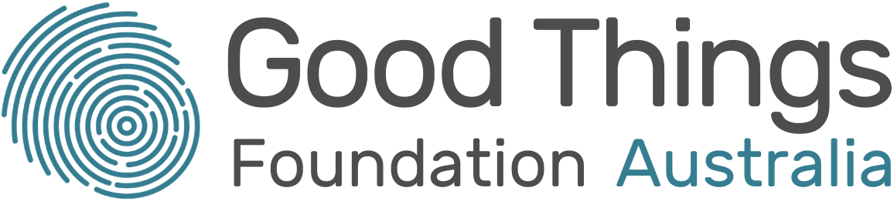

ACMA (2021) Communication and Media in Australia. How we use the internet
Thomas, J., Barraket, J., Parkinson, S., Wilson, C., Holcombe-James, I., Kennedy, J., Mannell, K., Brydon, A. (2021). Australian Digital Inclusion Index: 2021. Melbourne: RMIT, Swinburne University of Technology, and Telstra, p. 5
Thomas, J, Barraket, J, Wilson, CK, Holcombe-James, I, Kennedy, J, Rennie, E, Ewing, S, MacDonald, T, (2020), Measuring Australia’s Digital Divide: The Australian Digital Inclusion Index 2020, RMIT and Swinburne University of Technology, Melbourne, for Telstra, p. 15
Ibid, p. 19
Ibid.
Featherstone, D (2020) Remote Indigenous Communications Review. Telecommunications Programs and Current Needs for Remote Indigenous Communities, ACCAN, p. 7
Ibid.
Australian Government, Closing the Gap in Partnership (2020), National Agreement on Closing the Gap
Featherstone (2020), p. 7, 9
Preston, B (2020) Digital Inclusion for all Public School Students, Barbara Preston Research, p. 5
Thomas et al (2020), p. 19
Featherstone (2020), p. 9
Thomas et al, (2020), p. 21
Notley, T Chambers, S Park, S Dezuanni, M (2021) Adult Media Literacy in Australia: Attitudes, Experiences and Needs, WSU, QUT and University of Canberra, p. 68
eSafety Commissioner (2019) eSafety for Women from Culturally and Linguistically Diverse Backgrounds, p. 4
eSafety Commissioner (2019) Online Safety for Aboriginal and Torres Strait Islander Women Living in Urban Areas , p. 58
McCosker, A, Tucker, J, Critchley, C, Hiruy, K, Walshe, J, Suchowerska, R, Barraket, J. (2020) Improving the digital inclusion of older Australians: The social impact of Be Connected. Swinburne University of Technology, Melbourne, p. 9
Ibid, p. 37
AIHW (2016). Australian Burden of Disease Study: Impact and causes of illness and death in Aboriginal and Torres Strait Islander people 2011. Australian Burden of Disease Study series no. 6. Canberra: AIHW.
Hobson, G.R, Caffery, L.J, Neuhaus, M, Langbecker, D.H, (2019) Mobile Health for First Nations Populations: Systematic Review. JMIR Mhealth Uhealth, 7(10)

