Good Things Foundation Australia

Submission & Recommendations

National Digital Health Strategy

Good Things Foundation Australia submission
November 2021

Table of Contents
Introduction 3
Key barriers 3
What barriers do the groups you represent face in incorporating digital health day-to-day? 3
What barriers do these groups face? 4
Why do these groups face barriers? 6
Solutions 7
Changes to digital health that need to be made to achieve its benefits 7
Other information towards the digital health strategy in Australia 8
About Good Things Foundation Australia 11
Acknowledgement of Country 11
Contact 11

Introduction
It is important that everyone can access the health information and services they need. In today’s digital world, this means having the connectivity, ability and affordability to be safe and confident online.
The COVID-19 lockdown restrictions across Australia have changed the way we live and work, and highlighted digital inclusion as an issue for all health and community services. As the world increasingly moves online, more people are at risk of being left behind in their ability to access information, timely support, find reliable information, and stay connected and well.
There is a risk in healthcare digitising that some vulnerable patients and populations will be unable to benefit from it exactly when they most need it, due to the digital divide.
Good Things Foundation Australia works to advocate for and provide practical support for the 1 in 4 Australians that are estimated to be digitally excluded. We thank the Australian Digital Health Agency for the opportunity to make this submission towards the development of the National Digital Health Strategy. Responses in this submission relate directly to the key questions posed during the consultation process.

Key barriers

What barriers do the groups you represent face in incorporating digital health day-to-day?
The key barriers the groups that Good Things Foundation Australia represents face are best categorised using the ADHA options as:
- Cost/Funding Model
- Complexity
- Unreliable performance
- Poor user experience and/or interface
- Privacy and security concerns
- Inadequate training and education
- Insufficient infrastructure and/or support
- Access to the latest digital health tools and technologies
- Other

What barriers do these groups face?
Across Australia, the digital divide impacts many people and communities. While some evidence indicates that the pandemic has seen the rate of people completely offline fall, one in four people are still digitally excluded.
People who are on low incomes, have lower levels of education, have a disability, are older or have a mobile-only connection, First Nations people and people living in regional/rural Australia are particularly at risk of being digitally excluded.
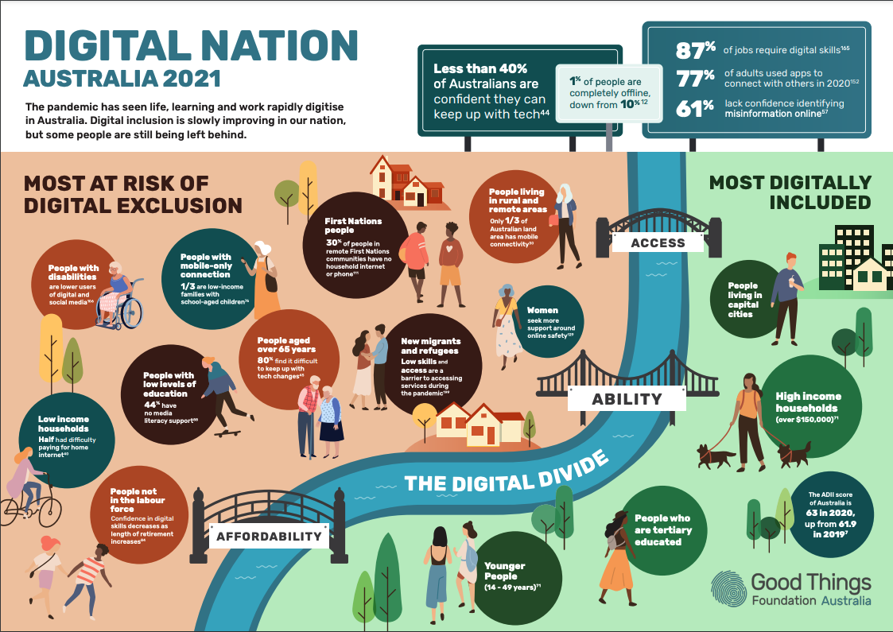
Good Things Foundation’s Digital Nation Australia 2021 report brings together the latest research from government, corporates and academia.
People who are digitally excluded do not have the digital literacy, knowledge of or affordable access to the tools and resources to help them navigate through the health system and find the required services, resources and supports they need to manage their health. This puts them at a disadvantage compared to digitally included Australians. We call this the ‘digital health divide’.
The digital health divide is a critical equity issue in the rapid expansion of digital technology in our health system. The digital health divide means that many people, particularly vulnerable populations, are at risk of being further marginalised through poor access to online health information and services.
Particularly since COVID-19, there is a rapidly increasing rate of health services, including mental health, being delivered online. People that have no, or limited, internet use and low digital media literacy are also disadvantaged by missing out on the wealth of reliable health information available online. The impact of a broad lack of digital media literacy was never more apparent than during the COVID-19 pandemic where widespread misinformation about the virus, treatments and vaccinations have had a significant negative impact on the population over the past 18 months. 61% of Australians are not confident identifying misinformation online, showing the critical need for broadscale media literacy support in health beyond just those who are digitally excluded.
This digital divide is entrenched further by existing online health services such as My Health Record offered by the Government being difficult to use for people with low digital skills. Experience from our digital health literacy programs indicates that a high level of basic digital skills are needed to access these services. Even if people have these skills, having the confidence to trust the security of these systems and understand implications on privacy emerged as specific concerns. People also lacked awareness of the potential benefits that digital health technologies could bring - even things as simple as being able to count steps on a smartphone. To support our programs, we developed online learning resources to help bridge this gap, however these resources are just the beginning of what is needed and what is possible:
- See our digital health online learning modules
- See our Get Online Week campaign health resources for beginners
Digital support for all sectors of the community is critical to avoid a growing divide between those with the skills, connectivity and technology to access online health services and information, and those that don’t.
Good Things Foundation Australia and our 3,500-strong network of community organisations work to support people in Australia that are digitally excluded or have low digital skills and confidence. Digital exclusion is a complex issue and involves a lack of access to digital health tools and technology, lack of ability (including motivation) to use it confidently and safely, and lack of affordable internet-connected devices capable of facilitating use of online health services. People particularly at-risk of missing out are those that are most digitally excluded; communities who already have higher incidences of chronic health conditions or are at greater risk of mental health issues.

Why do these groups face barriers?
The populations affected by the digital divide are the same populations experiencing higher rates of chronic disease, and poorer healthcare outcomes. The people that are at higher risk of digital exclusion are more likely to be from the lowest socioeconomic groups – people on low incomes, that are unemployed, that have low levels of education. These groups are also more likely to have higher rates of illness and chronic disease such as diabetes, are more likely to suffer heart stroke and vascular disease, have chronic kidney disease, have a disability and live shorter lives compared to people from higher socioeconomic areas, so are doubly disadvantaged through low digital literacy and a lack of affordable access to the internet.

Solutions

Changes to digital health that need to be made to achieve its benefits
In partnership with Australian National University, Good Things Foundation Australia last year commenced a series of roundtable discussions focussed on better understanding the digital health divide. We brought together the community sector, healthcare providers, government and academia to explore the issue of the 'digital health divide' and develop a series of recommendations. The consensus achieved by participants in the first two roundtables was clear - multiple solutions are needed to realise the potential of digital health for all Australians.
High priority recommendations were identified by participants to inform future programs and policies.
Recommendations from Roundtable 1:
- Meaningfully co-design and partner with communities in the long-term to support all Australians, particularly those most vulnerable, to use digital technology to support their health and wellbeing.
- Build the confidence of clinicians and consumers on how to use digital health and embed digital health literacy in training and support services.
- Consider piloting digital health interventions within the context of primary care, supporting both providers and patients.
Recommendations from Roundtable 2:
- Patients and consumers need targeted support and education to develop the skills and confidence to use different forms of health technology, such as telehealth and online information resources.
- Reliable and affordable technology and connectivity must be provided to ensure equitable access to digital health services.
- Health care providers need digital assistance and upskilling on using digital health technologies, such as telehealth.
From these recommendations it is clear that skills and confidence in both consumers and clinicians will be a key enabler of emerging digital health technologies being embedded into day-to-day life of all Australians. This will require funding and dedicated support from across sectors to support those hardest-to-reach through offline interventions, programs and campaigns.
- Read the full report and recommendations from the roundtables

Other information towards the digital health strategy in Australia
For the National Digital Health Strategy to be realised, it needs to be developed in the context of a national, coordinated digital inclusion strategy. While work is underway and some information has been released on this through the Digital Economy Strategy, a holistic and comprehensive plan is required for all Australians to benefit equally from the digital revolution currently underway, including in healthcare.
In addition to this national strategy, targeted and funded health-specific digital inclusion initiatives are needed to realise the full potential of digital health in Australia. Several examples are available to learn from in terms of closing the digital health skills divide for consumers.
Good Things Foundation is currently working in partnership with Consumers Health Forum of Australia on the third of the recommendations from Expanding Digital Health Roundtable 1 to further develop the concept of the ‘Digital Health Navigator’ into a formal approach to pilot. This pilot requires funding to be tested in real-world scenarios.
The Digital Health Navigator model will be complementary to our Health My Way program - our successful, community-led digital health literacy program. Funded by ADHA, this program worked alongside 75 Network Partners, with over 30 located in regional/remote communities.
Nationally, 232 digital mentors were trained by Good Things Foundation to support over 3,000 learners develop basic digital health skills, and overall the program engaged over 6,000 community members around the benefits of digital health. This program was open to all Australians over the age of 18, with 79% of participating organisations reporting that the program increased participants’ access to digital health literacy support, and 92% stating the program also increased participants' social interactions and connections.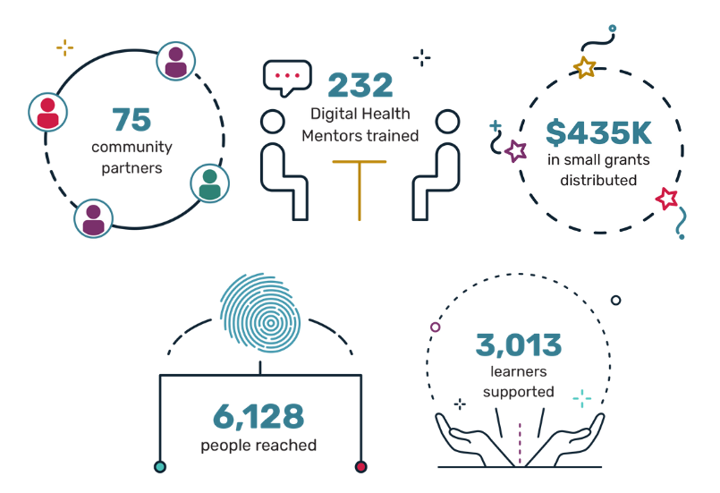The impact of Good Things Foundation Australia’s Health My Way program in numbers.
This program successfully extended on basic digital skills programs such as Be Connected, providing a model for targeted extension programs to focus on specific identified areas of need for digital health ability.
Community education programs like Health My Way need to be extended so all Australians have the skills to adopt telehealth and digital health initiatives, and find reliable health information online. Community-led digital health literacy programs have supported people during the pandemic to manage their health and wellbeing using tools like My Health Record, and find reliable sources of COVID-19 and online mental health information. As the health landscape rapidly transforms, more funded support is needed to maximise uptake of telehealth and government health initiatives and reduce the risk of misinformation or low uptake.
- Read more about the social impact of Health My Way
- Read more about our regional approach to digital health education
- Read how digital health literacy programs can be delivered in community settings
In the UK, Good Things Foundation has worked in partnership with their network of community organisations and the National Health Service to develop and deliver the Widening Digital Health Participation program. This digital health literacy program has been delivered through establishing ‘digital health hubs’ in local communities and co-designing resources and programs to meet the community's needs.
This program has resulted in:
- £6.40 ROI for every £1 invested in digital health inclusion
- 90% of people supported improved their wellbeing as a result of digital inclusion activities
- 51% felt more informed about their health
- 50% said they feel less lonely or isolated.
Again, this shows the wide-ranging positive impact partnership-based and community-led digital health literacy programs can have, and how they need to be funded and fully incorporated into the national digital health strategy moving forward.

About Good Things Foundation Australia
Good Things Foundation Australia is a social change charity, helping people to improve their lives through digital. We work with partners in thousands of communities across Australia and the UK.
In Australia, we have built and manage the Australian Government funded Be Connected Network of 3,500 community partners and deliver a small grants program to support people over 50 to learn essential digital skills. We coordinate the annual digital inclusion campaign Get Online Week, which last year supported 23,500 people to improve their digital skills. With the support of the Australian Digital Health Agency and our network of community organisations, we assisted adults of all ages to improve their digital health literacy through our Health My Way program.
Good Things Foundation has run digital inclusion projects in the UK for over ten years and worked in Australia since 2017.
Learn more about our work:
- Information about our projects
- Our research and publications
- Our work in the UK

Acknowledgement of Country
Good Things Foundation Australia acknowledges that we work on the land of the Gadigal people of the Eora Nation. We pay our respects to elders - past, present and future.

Contact
Liz Jones
Director of Partnerships & Growth
Good Things Foundation Australia
P: 02 9521 9292
E: liz.jones@goodthingsfoundation.org
www.goodthingsfoundation.org

Australian Digital Inclusion Index 2021
ACMA (2021) Communication and Media in Australia. How we use the internet
Thomas, J., Barraket, J., Parkinson, S., Wilson, C., Holcombe-James, I., Kennedy, J., Mannell, K., Brydon, A. (2021). Australian Digital Inclusion Index: 2021. Melbourne: RMIT, Swinburne University of Technology, and Telstra, p. 5
Thomas, J, Barraket, J, Wilson, CK, Holcombe-James, I, Kennedy, J, Rennie, E, Ewing, S, MacDonald, T, (2020), Measuring Australia’s Digital Divide: The Australian Digital Inclusion Index 2020, RMIT and Swinburne University of Technology, Melbourne, for Telstra, p. 15
Notley, T Chambers, S Park, S Dezuanni, M (2021) Adult Media Literacy in Australia: Attitudes, Experiences and Needs, WSU, QUT and University of Canberra, (2020), p 8

