Report (Easy Read)

Bridging the Digital Divide for people with intellectual disabilities

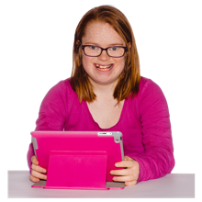 | Good Things Foundation and Down Syndrome Australia are working together on a project.  This goal of this project is to help young people with an intellectual disability learn about how to use technology.
In 2021 we had a meeting to understand people’s ideas.

People at the meeting talked about how to support people with intellectual disability to get online.

This Easy Read document is a summary of what people said at this meeting.

A lot of different people attended the meeting including:

- people with a disability
- family members
- advocates (people who speak up for disability rights)
- researchers (people who study new information or ideas about things)
- policy makers (people who make plans for the government and other organisations on topics like disability and technology).

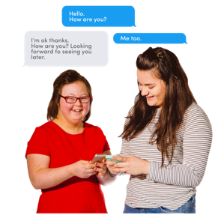 | These are some of the things we heard about at the meeting.  Being able to use technology is important.  People use technology to stay connected with friends, to learn, and to do their job.
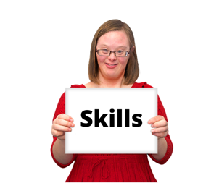 | At the meeting we talked about 3 main barriers to using technology:  1. Ability. Not everyone has the skills they need to get online.
2. Access. Not everyone is able to use the technology.

This can be because the technology is difficult to use or it is hard to find the right technology.

People with an intellectual disability do not always get a say about when and how they can use technology.

People with intellectual disability and their families can also be worried about safety.

 | 3. Affordability. Not everyone can afford to pay for technology.
 | People with intellectual disability are more likely than other people to find it hard to use technology.
Sometimes this happens because people do not have a laptop or tablet that they can use. Or they do not have internet at home.

Some people do not know how to use technology or do not have a chance to learn.

Other people can not use technology because it costs too much money.

People with intellectual disability sometimes need more help to stay safe online.

Worries about safety can mean sometimes people do not want to use technology. Or their family or supporters do not want them to use it.

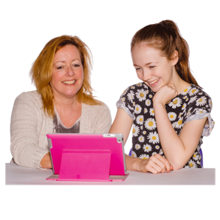 | Families and supporters can help people with intellectual disability to use technology.  But they might also need help in using technology.
The Coronavirus has meant that people are using technology more than before for things like:

- health care
- employment
- therapy supports
- connecting with friends and family.
There are a number of programs to help people get online.

Some of these programs have information for people with intellectual disability:

Online Safety Academy

Down Syndrome Australia

eSafety Commissioner

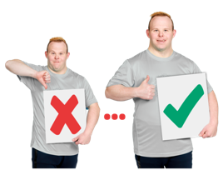 | At the meeting, we made recommendations about how to make things better for people with intellectual disability.  1) The Government should pay for a program to support people with intellectual disability to learn about technology.  2) The Government must make sure that all websites and information can be used by people with intellectual disability. This includes providing information in Easy Read.  3) People with intellectual disability and their families should have support to choose technology that will work well for them.  4) National Disability Insurance Agency (NDIA) and Department of Social Services (DSS) should look at how they can support people with a disability to use technology.  5) Every National Disability Insurance Scheme (NDIS) plan for people with an intellectual disability should include funding for technology support.  This is money to help someone to learn to use and access technology.

