Good Things Foundation Australia Pre-Budget Submission 2022/23
January 2022

Acknowledgement of Country 2
Executive Summary 3
Introduction 4
Essential digital skills programs are needed to support priority groups 6
Women in the workforce 6
People with disability 7
CALD Communities 7
First Nations people 7
Recommendations 8
Support adoption of telehealth and digital health initiatives 10
Recommendations 10
Improve digital media literacy and online safety for vulnerable people 12
Recommendations 13
Affordable internet access for all Australians 14
Recommendations 15
About Good Things Foundation Australia 16
Contact 16

Acknowledgement of Country
Good Things Foundation Australia acknowledges that we work on the land of the Gadigal people of the Eora Nation. We pay our respects to elders - past, present and future.

Executive Summary
The digital divide is a significant issue in Australia, particularly with the rapid pace of digitisation brought forward by the COVID-19 pandemic. Without urgent action, the digital divide is at risk of becoming even wider.
A digitally included country is one where all citizens can participate in the rapidly transforming digital economy, find and maintain work, maintain social connections, access online government and health services, and find reliable information, especially in times of crisis.
To support our communities to recover from the pandemic and become digitally resilient participants of the digital economy, this Federal Budget the Australian Government must:
- Provide funding for community-based essential digital skills programs to ensure all Australian adults are work-ready for the new economy. Particular focus needs to be given to supporting women in the workforce, people with disability, First Nations people and CALD communities.
- Extend community education programs so all Australians have the skills to adopt telehealth and digital health initiatives. Community-based digital health literacy programs have supported people during the pandemic to manage their health and wellbeing using tools like My Health Record, and find reliable information online. As the health landscape rapidly transforms, more support is needed to maximise uptake of telehealth and government health initiatives.
- Establish digital media literacy programs targeting adults with low digital capability to reduce online harms and prepare for emergencies. Locally delivered but nationally coordinated community education programs are needed to support vulnerable adults to safely navigate the online world, find reliable information (particularly in a crisis) and understand how to report harms and keep their families safe online.
- Ensure everyone has an affordable internet connection at home and an appropriate digital device to use it to create a world-leading digital economy.

Introduction
The COVID-19 pandemic saw a rapid increase in digitisation in all aspects of our society. Transitioning to a digital economy has been recognised as key to our nation’s economic recovery from the impact of COVID-19 and to our future prosperity. Never before has it been so important for everyone to be digitally capable, confident and safe online.
The pandemic and associated lockdowns saw rapid digital transformation of many workplaces and essential services. During the national lockdown, Australian adults increased their internet usage, seeing it as essential for paying bills, shopping, accessing news and information, staying in touch with loved ones, working and entertainment.
However, 1 in 4 Australians are digitally excluded. Less than 40% of Australians feel that they can keep up with the rapid changes in technology our society is experiencing. This puts many people at extreme risk of being left behind as our economy transforms.
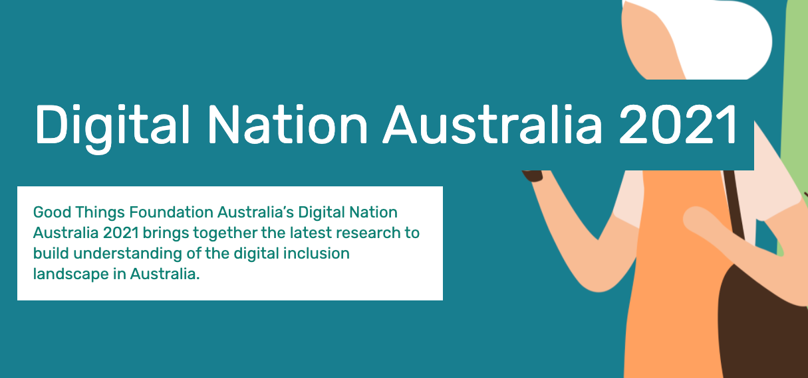
Three main factors influence a person’s ability to cross the digital divide and make the most of the opportunities available: ability, affordability, and access. High levels of inclusion in all three areas are required to ensure that people and communities are 100% digitally included.
Read more about
digital inclusion in
Good Things Foundation Australia’s Digital Nation 2021 report

If we don’t invest now, Australia will not be able to take full advantage of our transition to a digital economy.
Good Things Foundation Australia thanks the Australian Government for the opportunity to make this submission to the 2022/23 Federal Budget and recommends action on four priority area to close the digital divide:
- Essential digital skills programs for priority groups including women re-entering the workforce, people with disability, CALD communities and First Nations people.
- Adoption of telehealth and digital health initiatives through extending nationally coordinated community-based education programs
- Digital media literacy for vulnerable adults to reduce online harms and assist communities to find reliable information.
- Affordable internet access and devices for all Australians to maximise participation in the digital economy.

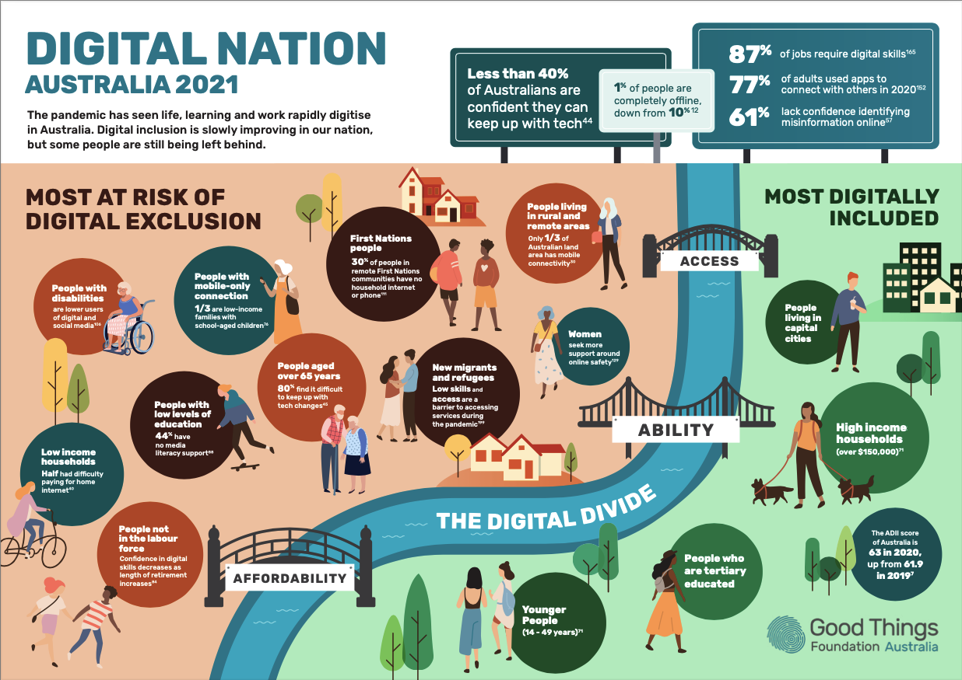
Good Things Foundation’s Digital Nation Australia 2021 infographic
showing the key digital inclusion challenges in Australia

Essential digital skills programs are needed to support priority groups
Invest in nationally coordinated, community-based digital upskilling programs that reach priority groups at higher risk of being left behind.
As a world leader in delivering digital inclusion programs, we know that digital skills programs work when there is a combination of high-quality online learning resources with grant-funded, tailored support in local community settings. The Australian Government-funded Be Connected program has tested this model for people aged over 50 years and shown that it works. It has reduced isolation, increased social connections, and increased online safety as well as rates of digital literacy, wth a social return on investment of $4 for every $1 invested. However, this program only supports those aged over 50 years.
- Read more about the impact of the Be Connected program
The Productivity Commission has also identified that foundational work-ready digital literacy programs need to be delivered through channels like community adult education, in addition to school and VET providers, to reach those who would not engage in formal education. Critical community-based infrastructure to rapidly scale and implement digital literacy programs to provide this support are already in place, but they need funding and support to reach those most at risk of digital exclusion.
While many people could benefit from essential digital skills support, tailoring programs towards people in several priority groups will see the most impact from community-based digital upskilling initiatives.

Women in the workforce
Women are less digitally included than men in Australia, and have been harder hit by job losses during the pandemic. Investing in improving digital capabilities is a key strategy to enabling women to return to the workforce and fully participate in the digital economy. In addition to helping women back into the workforce in the short term, there is also a need for women to improve their digital skills to maintain existing jobs and participate in growth industries such as aged care, healthcare, social services, and disability support services. Support should be targeted towards women with low or no digital skills, in low income families, who are unemployed, or in workplaces at risk of automation or newly requiring digital skills.

People with disability
People with disability are more likely to be digitally excluded in Australia. Since 2014, the digital inclusion gap for Australians with disability has changed very little. The Australian eSafety Commission has also reported people with disability being more likely to experience online safety issues such as cyber-bullying, harassment, image-based abuse and technology facilitated abuse. Our work with Down Syndrome Australia on a pilot digital skills program for young people for intellectual disability is showing that additional, tailored supports are needed for people to gain the essential online safety, communications and work-ready skills required to equally participate in modern life.
- Read about our pilot program for young people with intellectual disability

CALD Communities
Culturally and Linguistically Diverse (CALD) communities, particularly newly arrived migrants or refugees, could particularly benefit from community-based, culturally appropriate digital inclusion support to be work-ready as the economy transforms. For newly arrived migrants and refugees in CALD communities, digital exclusion can have significant impacts on successful settlement in Australia, including their ability to find and maintain work or establish small businesses and participate in professional development and training opportunities. Trusted support in familiar community environments would assist to reduce the digital skills divide for this priority group and improve employment outcomes.
- See our recent Victorian Parliament submission
- See our report on increasing Digital Participation of new Migrants & Refugees

First Nations people
Lower levels of affordable access and online participation means that First Nations peoples in Australia are more likely to experience exclusion from our digital society. Equal digital inclusion of First Nations people has recently been recognised as essential to Closing the Gap, being identified as one of the 17 national targets to ensure equal access to information and services in the National Closing the Gap Agreement. The work of organisations such as First Nations Media (inDigiMOB) and the National Centre for Indigenous Excellence has helped to identify the issues around the digital divide for Aboriginal and Torres Strait Islander communities and have begun to close the skills gap. Additional funded, co-designed support for digital ability programs is required as part of the implementation of the national Indigenous Digital Inclusion Plan.
- See our Indigenous Digital Inclusion Plan submissions

Recommendations
With minimal additional investment, existing community infrastructure can be extended upon so that people in the identified priority groups can access free, digital skills support. This would ensure that everyone can equally get back into the workforce, upskill, access online services, and participate in the rapidly transforming digital economy as Australia recovers from the pandemic:
- Invest $5.5m per year over 5 years in a nationally coordinated, community-based support program to deliver the work-ready digital skills to find and maintain employment for women.
- $1.5m per year to coordinate and capacity build a national network of digital mentors in community-based organisations, upskilled and resourced to deliver work-ready digital skills programs and design individual learning plans to women and small business owners and employees.
- $4 million per year in small grants for community organisations to support personalised digital mentoring and work-ready upskilling for women.
- Invest $3.5m per year over 3 years to expand the existing pilot for young people with intellectual disability into a nationally coordinated, community-based support program to support people with disability to gain essential digital skills. This must include funding to support program coordination and accessible resources development, small grants to support delivery through existing community-based organisation networks and train-the-trainer packages for digital mentors.
- Invest in a multi-year, culturally appropriate and community-based essential digital skills education program for First Nations people as part of the implementation of the Indigenous Digital Inclusion Plan. This must be co-designed and run in partnership with First Nations owned and community-controlled organisations.
- Invest in a tailored essential digital skills education program for CALD communities, focusing on newly arrived migrants and refugees, ensuring funding is available for appropriately translated and accessible materials, train-the-trainer activities for digital mentors, and small grant-funding for community-based delivery organisations.

Support adoption of telehealth and digital health initiatives
Invest in community education programs that support skills to access telehealth and digital health initiatives.
While significant advancements have been made in digital health during the pandemic, one of the most significant barriers facing the digital health agenda is how to engage those hardest-to-reach with low digital health literacy skills or confidence, and introduce them to online health information and services. Those most likely to be missing out on the benefits of digital health due to time, cost, preference or low digital ability, are also more likely to have higher healthcare needs.
Digital upskilling enables people to benefit from important government initiatives such as My Health Record and electronic prescribing, medicare funded telehealth appointments, access information through Health Direct or online mental health services such as Head to Health, access a range of online information and resources safely and understand if that information is reliable and trustworthy. Integrating this upskilling with support from medical professionals will gain the most impact. Trialling and evaluating the introduction of a digital health support role embedded in general practice is a key recommendation of senior policy makers, researchers and other stakeholders across government, research and community sector.
- See our Expanding Digital Health Roundtable recommendations
Good Things Foundation Australia’s Health My Way program, funded by the Australian Digital Health Agency, was delivered through our Network in 75 communities across Australia during 2019-2021. This program showed that despite the challenges of the pandemic, with funded, locally provided, tailored support, people at risk of digital exclusion can better participate in the digital health environment.
- Read about the social impact of the Health My Way program

Recommendations
- Invest $3.5m per year for 3 years to nationally scale digital health community education programs to consumers across 500 locations. These programs will build capability in accessing telehealth and digital health initiatives through community-based learning models. This must include:
- $1m per year to capacity build and coordinate a national network of community organisations that specialise in skills provision to deliver digital health literacy support. This would include upskilling community sector staff and volunteers on best practice digital health mentoring, creating mentoring resources, and developing up-to-date, quality online digital health learning content that can be delivered through blended face-to-face and remote delivery models.
- $2.5m per year in small grant-funding distributed nationally across 500 participating community organisations, enabling their program delivery.
- Invest $2m over 12 months in a digital health navigators pilot program to trial a new role that supports both practitioners and health consumers to use technology to better manage their health and care.

Improve digital media literacy and online safety for vulnerable people
Invest in digital media literacy programs delivered through community organisations for adults with low awareness to reduce online harms and the spread of misinformation.
61% of adults in Australia lack confidence identifying misinformation online. We know misinformation can cause real world harms, ranging from health and safety to electoral integrity. The ACCC’s 2019 Digital Platforms Inquiry report recommended that the Australian Government establishes a community-based education program that develops resources and trains community organisations (including libraries, seniors centres and community centres) to upskill all Australians in identifying and scrutinising online news, building on the model of the Be Connected program. The Royal Commission into National Natural Disaster Arrangements also highlighted the important role of community organisations in disasters and the need for national community education campaigns on finding reliable and timely information in preparing people ahead of emergency situations.
- See our submission to the Bushfire Royal Commission
Programs exist for children to build their digital media literacy, such as through schools, the ABC and the work of organisations like the Alannah and Madeline Foundation. Programs are now needed to target other vulnerable groups, such as adults who have low levels of digital skills.
Those who are most at risk of digital exclusion plus those with low levels of understanding of misinformation and online harms could benefit from tailored programs and supports. In order to reduce online harms for vulnerable groups, and help people with low digital media literacy skills to navigate and find reliable information, especially during a crisis, an effective, funded community-education based approach is required.

Recommendations
- Invest $1.5m for a nationally coordinated, locally delivered emergency digital preparedness 18 month pilot program delivered through existing community infrastructure channels, including: small grant funding for community organisations hosting digital skills training and funding for a train-the-trainer program for digital mentors.
- Invest $3m per year in community-based education programs to upskill people with low digital literacy on reporting and managing online harms and finding reliable information online to reduce the unintentional spread of misinformation.

Affordable internet access for all Australians
Affordable access is a big barrier to full and equal participation in the digital economy for many Australians, particularly those on low incomes.
All Australians must have access to an affordable, internet-connected device at home to be able to find and maintain work, access essential services and stay socially connected. A lack of access to internet connected devices at home at affordable rates is a major barrier to the full participation of people in the digital economy and the continuous improvement of their digital skills.
From research with the Be Connected Network, we know that many who need digital skills support do not have access to an appropriate, internet connected device they can use at home during the pandemic. Even after loan device programs were implemented, 74% of our network community organisations delivering digital skills programs to seniors said their learners were lacking access to appropriate devices and data. And, it’s not just older Australians who are impacted. A survey of 500 low-income households saw half of those with a home internet connection reported difficulty paying costs associated with the service.
- Read our case study on loan devices from Grafton, NSW
- Read about the digital device loan program at CIRE, VIC
While the NBN has improved broadband coverage, less than a third of the Australian land mass has mobile coverage. This leaves large areas in regional Australia not covered, or covered by only one service provider limiting choice and market competition.
- See our submission to the Regional Telecommunications Review 2021
While mobile-only users are less digitally included than people with other connections, mobile-only use is a key strategy people implement to overcome connectivity barriers. The coverage issues of mobile networks in regional Australia has the potential to have a significant impact on low income community members, given they are more likely to be reliant on a mobile-only service. Further, a relatively high proportion of First Nations peoples are mobile-only users with prepaid connectivity (35.0% versus the national average of 19.9%), which has a higher cost per unit than fixed internet connections.
- Read about Good Things Foundation’s solution to digital poverty in the UK - the National Databank
More investment is needed to ensure all Australians at higher risk of digital exclusion have access to appropriate and affordable internet connected devices at home.

Recommendations
- Improve digital access for Australians at risk of digital exclusion by ensuring affordable and appropriate internet connected devices are available in all homes during the COVID-19 recovery period and beyond.

About Good Things Foundation Australia
Good Things Foundation Australia is a social change charity, helping people to improve their lives through digital. We work with partners in thousands of communities across Australia and the UK.
In Australia, we have built, upskilled and manage the Australian Government funded Be Connected Network of 3,500 community partners and grants program to support people over 50 to learn essential digital skills. The Be Connected digital literacy program has so far reached over 1 million people.
We coordinate the national digital inclusion campaign Get Online Week which last year supported 15,000 people through online and offline digital skills events. With the support of the Australian Digital Health Agency and our network of community organisations, we have assisted adults of all ages to improve their digital health literacy through our Health My Way program.
Good Things Foundation has run digital inclusion projects in the UK for over ten years through the 5,000 strong Online Centres Network and worked in Australia since 2017.
Learn more about our work: www.goodthingsfoundation.org.au
See our resources for community organisations: www.beconnectednetwork.org.au

Contact
Jess Wilson
CEO
Good Things Foundation Australia
e: connect@goodthingsfoundation.org
p: (02) 9051 9292

eSafety Commissioner (2020) COVID-19 Impact on Australian adults’ online activities and attitudes, p. 3, 6
Thomas, J, Barraket, J, Wilson, CK, Holcombe-James, I, Kennedy, J, Rennie, E, Ewing, S, MacDonald, T, (2020), Measuring Australia’s Digital Divide: The Australian Digital Inclusion Index 2020, RMIT and Swinburne University of Technology, Melbourne, for Telstra, p. 15
https://digitaleconomy.pmc.gov.au/ accessed 27 January 2022
Thomas et al, (2020), p. 18
Thomas et al (2021), p. 5
Royal Commission into National Natural Disaster Arrangements (2020) The Royal Commission into National Natural Disaster Arrangements Report, p. 247
ACCC (2019) Digital Platforms Inquiry, Final Report p. 33
Thomas, J., Barraket, J., Parkinson, S., Wilson, C., Holcombe-James, I., Kennedy, J., Mannell, K., Brydon, A. (2021). Australian Digital Inclusion Index: 2021. Melbourne: RMIT, Swinburne University of Technology, and Telstra, p 5
Productivity Commission (2020), National Agreement for Skills and Workforce Development Review: Productivity Commission Study Report, p. 29-30
Thomas et al. (2021) p. 4
Infrastructure Australia (2019) An Assessment of Australia’s Future Infrastructure Needs. The Australian Infrastructure Audit 2019, p. 568
Thomas et al, (2020), p. 18
Ibid. p. 19
Ogle, G Law, R (2020) Connectivity Costs II. Telecommunications Affordability and Waged Poor Households, SACOSS, ACSS, TCSS and ACT SS, p. 3
Good Things Foundation Australia (2020) Reinventing Digital Literacy Support in a Crisis. The Impact on Community-based Digital Inclusion Programs, p. 11
McCosker, A., Tucker, J., Critchley, C., Hiruy, K., Walshe, J., Suchowerska, R., Barraket, J. (2020) Improving the digital inclusion of older Australians: The social impact of Be Connected. Swinburne University 32 of Technology, Melbourne, p. 8
- eSafety Commissioner (2020) Protecting voices at risk online, p. 13
Settlement Council of Australia & Good Things Foundation Australia (2021) Supporting the Digital Inclusion of New Migrants and Refugees, p. 10
Australian Government, Closing the Gap in Partnership (2020), National Agreement on Closing the Gap
https://www.pmc.gov.au/office-women/economic-security/wess/repair-and-rebuild-womens-workforce-participation-and-further-close-gender-pay-gap accessed 27 January 2022
Notley, T Chambers, S Park, S Dezuanni, M (2021) Adult Media Literacy in Australia: Attitudes, Experiences and Needs, WSU, QUT and University of Canberra, p. 10
ACMA (2020), Misinformation and news quality of digital platforms in Australia: A position paper to guide code development p. 11
Thomas et al (2020), p. 19, 21
Ibid p. 5
Australian National University & Good Things Foundation Australia (2021) Expanding Digital Health. Realising the Promise of Digital Health for those who are Socio-economically Disadvantaged, p. 4

