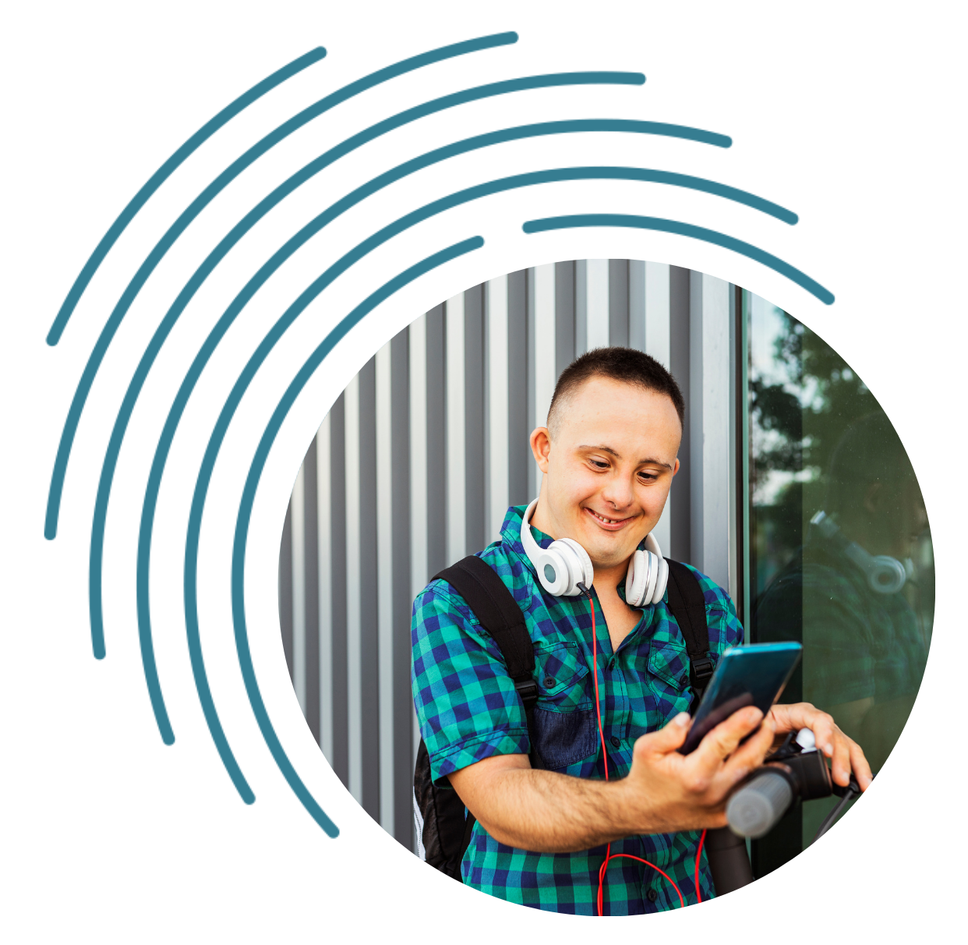

Bridging the digital divide for people with intellectual disability

Roundtable Report
February 2022

Table of Contents

Introduction 3
Context 4
Effects of COVID 5
Barriers to people with intellectual disability using technology 6
Ability 6
Access 7
Affordability 7
Support to get online - current resources and programs 7
Recommendations 8
Endnotes 10
Appendix 1 11
Agenda 11
Appendix 2 12
List of Attendees 12
Contact 14

Introduction
Good Things Foundation Australia and Down Syndrome Australia are collaborating on a project that aims to support young people with intellectual disability to develop essential digital skills. As part of this project, a roundtable was held bringing together people with intellectual disability, researchers, family members, disability service providers, advocates, and policymakers to:
- Highlight the issues of digital exclusion for people with disability
- Gain a greater understanding of the digital divide and the online safety risks for people with intellectual disability, and the current research and programs to address these needs
- Establish recommendations for future policy and programs.
The roundtable was co-chaired by Jess Wilson, Chief Executive Officer of Good Things Foundation Australia, and Ellen Skladzien, Chief Executive Officer of Down Syndrome Australia. To set the context for the discussion, presentations were given by:
- Kirrin Pereira and Eoin Gibson, Project Officers from Down Syndrome Queensland, on the results from a survey of young people with Down Syndrome and their families about their experience with digital technology
- Dr Iva Strnadová from the University of New South Wales on her findings on mobile technology and social inclusion, and
- Deborah Fulwood from a parent’s perspective.
These were followed by discussions in small groups around three key questions:
- What are some of the key barriers to people with intellectual disability using technology? What might help to overcome these barriers?
- From your knowledge and experience, what are the programs, learning resources, and approaches to addressing this as an issue (nationally or internationally)? What would work?
- What are the critical next steps for Australia to ensure that people with intellectual disability can equally access technology? How can we learn from the focus COVID has had on highlighting this as an issue?
This report summarises the issues discussed and provides recommendations for next steps in policy and program development.
The ‘Bridging the Digital Divide for Young People with Intellectual Disability’ project is funded by the Department of Social Services.

Context
The last year has seen an unprecedented focus on the use of digital technology to facilitate participation in almost all aspects of life. Digital inclusion is the ability to access and use digital technologies effectively,¹ so ensuring digital inclusion for all is one of the most important challenges facing Australia today. Without it, people are not able to fully participate in the digital economy and society, creating a digital divide between those who are able to access and use technology and those who cannot.

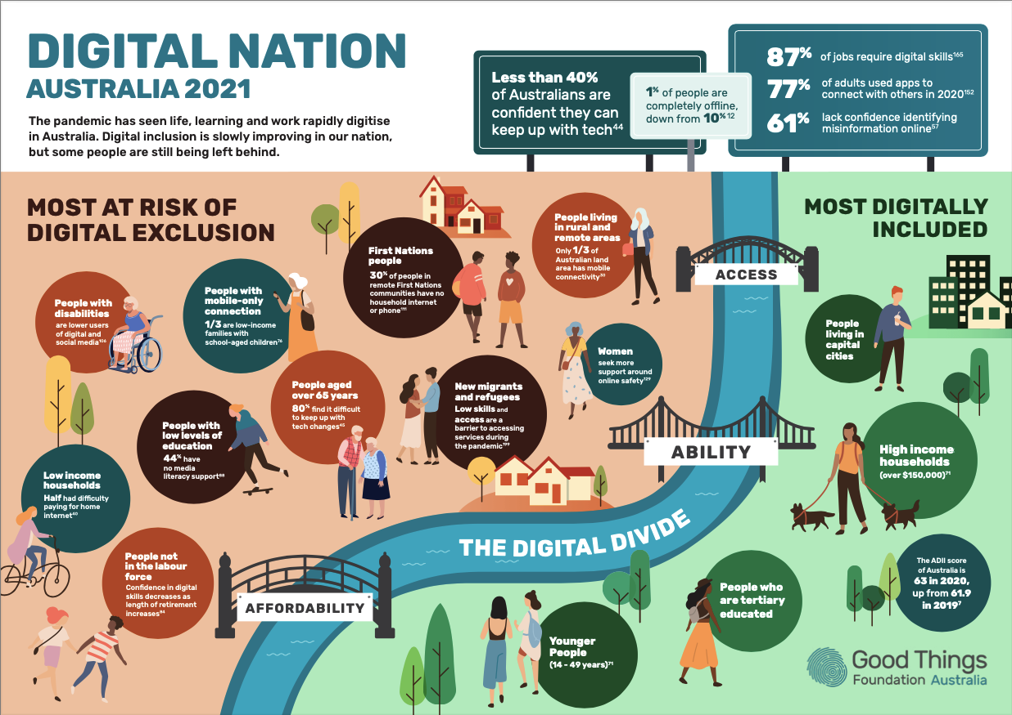
Good Things Foundation’s Digital Nation Australia 2021 infographic showing the key digital inclusion challenges in Australia.

Just like the broader population, being able to use technology helps people with intellectual disability have increased independence, participate in learning, look for work and stay connected with family and friends.² However, people with disability are more likely to be digitally excluded compared to other Australians.
People with disability score 9.1 points below the national average on the Australian Digital Inclusion Index score.³ This score measures digital inclusion across the three dimensions of Access, Affordability and Ability.
People with disability have been found to have:
- Lower use of technology and social media⁴
- Lower interest in new technology⁵
- Lower confidence and skills online⁶
- Issues with affordability and access to technology.⁷
Some of the reasons people with disability are more at risk of digital exclusion include:
- Lack of access to the internet and devices
- Lower digital skills and fewer opportunities to learn
- Socio-economic factors and high prices of technology.⁸
Online safety is a key area that needs to be addressed in relation to helping people with intellectual disability feel more comfortable and confident online. Once online, people with disability are at greater risk of online harassment, cyberbullying, unwanted contact and grooming, image-based abuse, online hate speech, cyber abuse, and technology-facilitated abuse.⁹ In addition, half of young people with a disability have talked to strangers online, compared to 37% of young people without a disability.¹⁰ Further, the eSafety Commission completed qualitative research of women with intellectual disability and the importance of digital safety skills when dealing with technology facilitated abuse.¹¹ It showed reliance on others for help with such devices could lead to abuse, another reason online skills and confidence is so important for people with intellectual disability.¹²
Families and carers supporting people with intellectual disability play a significant role in helping those they support to be more digitally included. Supporters tend to more often be women, have low income, be older, or may have lower levels of education,¹³ groups themselves more likely to be digitally excluded.¹⁴ Although parents and supporters can recognise the benefits of the person they support being online, another barrier to access can be parental protections.¹⁵

Effects of COVID
Prior to the pandemic, people with disability were already less likely to have access to online services¹⁷ and with many face-to-face services, social opportunities, health, therapy and support transitioning online due to lockdown restrictions, COVID-19 has seen the impact of the digital divide increase.¹⁸
As an example, in a UK survey, 75% of people with a learning disability reported their wellbeing was affected by the impact of COVID-19, compared to 37% of non-disabled people.¹⁹ However, those who were supported to learn how to use technology during COVID-19 lockdowns improved mental health and wellbeing.²⁰
The COVID-19 pandemic has shown how strong and resilient communities can be, and has sped up digital transformation agendas of governments and businesses. With access to key services requiring online interaction, including COVID information, vaccine certificates, employment support and healthcare, there is a need for resources, information and services to be accessible for all (e.g. available in Easy English). Government must now ensure everyone has affordable access to technology, as well as the ability to use it.
In response to the pandemic, the National Disability Insurance Scheme (NDIS) allowed participants to purchase low-cost tablets for telehealth/care or to participate in online video classes, as part of their packages²¹ and different advocacy and support groups have developed programs to support people to engage online. However, there is no national program that provides an integrated package of access to affordable devices and data and builds digital confidence, skills and online safety for people with intellectual disability. In addition, there are 286,000 people in Australia with intellectual disability,²² and only 92,000 NDIS participants with their primary disability reported as an intellectual disability.²³ This means there are around 194,000 people with intellectual disability who are not covered by NDIS, and were not supported with affordable access to devices.

Barriers to people with intellectual disability using technology
Attendees at the Roundtable identified three key barriers to people with intellectual disability using technology in line with the Australian Digital Inclusion Index definition of areas of digital inclusion:
- Ability
- Access
- Affordability

Ability
Not everyone has the skills to get online or can get the support they need to navigate the complexity of online tasks, systems and relationships. Without these skills or appropriate support, people with intellectual disability can struggle to interact with government services (eg. MyGov, the NDIA portal or the Disability Gateway) and stay connected with friends. However, it is also the case that people with intellectual disability feel worried or anxious about being online because of the risks surrounding cyberbullying and scams. People who have had support to build digital skills are able to participate more fully and confidently online.

Access
Difficulty accessing digital technology and data can occur for a number of reasons including:
- Accessibility of technology. This includes issues around design, availability of Easy Read materials online and other related issues.
- Finding the right technology. It is often difficult for people with intellectual disability to choose the right technology and data plans. It can also be hard to navigate the vast number of websites/apps that are available and to know which types of apps/technology would work best for them.
- Independence. People with intellectual disability have less agency in the decision making about when or how to use technology. An example includes lack of technology and/or internet connection in independent living units or shared supported accommodation.
- Online safety. Both people with intellectual disability and their families can be concerned about online safety. In some cases, parents limit access due to concerns about inappropriate content, strangers, and online abuse.
Access can affect people’s ability, as exposure to devices, apps and websites are important for developing online skills.

Affordability
Some people with intellectual disability have difficulty being able to afford technology. It was noted that some NDIS participants had been able to source devices through NDIS funding during COVID, but that there was a great deal of uncertainty about this process and many people with intellectual disability do not qualify for NDIS packages.

Support to get online - current resources and programs
In Australia, federally-funded digital literacy programs have shown the effectiveness of community-led programs to help people who are digitally excluded to build their confidence and get online. Examples of these programs include:
- Be Connected for people over 50
- Health My Way for adults to gain basic digital health skills
Simple resources for families can also be found on the Go-Digi website.
Although these programs include people with disability as a target group, they have not specifically included accessible resources for people with intellectual disability.
There are some accessible resources tailored for people with intellectual disability including:
- Easy Read resources which provide information about online tasks and online safety available from Down Syndrome Australia, Scope, and the eSafety Commissioner
- The Online Safety Academy, an online internet safety program for people with intellectual disability developed by the eSafety Commissioner and Endeavour Foundation
- There are also resources for disability workers, such as information surrounding online safety issues for people with disability
- In the UK, Digital Lifeline aims to help people with a learning disability gain access to devices and skills training. Early reports have shown improvements in learning skills, reaching goals, and feeling safer online.
Some content has been developed by large service providers, but may not be freely available outside the organisation or easily found online.

Recommendations
From discussions at the Roundtable on the context and barriers for people with intellectual disability getting online, the following five recommendations were made to address this digital divide.
- Ability - The Australian Government should fund a holistic program to increase the digital ability of people with intellectual disability.
This needs to include:
- A single digital literacy hub of accessible learning materials to support people with intellectual disability to build digital skills and confidence. This would include:
  - Easy read, videos, and interactive learning activities
  - Content for different learning levels and age groups
- Resources for families and support networks to build their digital skills and confidence. This should include information about safety and dignity of risk.
- Local face-to-face support to develop digital literacy through support from disability service providers or other community organisations that use a peer-mentoring model
- Access - Government needs to ensure all websites and key information resources are accessible for people with intellectual disability (available in Easy Read or Plain English formats).
Given the extensive use of digital communication in government services, this must include:
- Any new Government communication project having dedicated funding to consult on and address access issues for people with intellectual disability
- People with intellectual disability being commissioned to review and provide feedback on government websites/processes
- A requirement for all online government information to be accessible.
- Access - Support needs to be provided to people with intellectual disability and their families to choose the right technology and data plans.
The Accessible Telecoms project delivered by ACCAN could be extended to support this.
- Access - People with intellectual disability in shared accommodation should be supported to use technology
More work needs to be done by relevant agencies, like the Department of Social Services and National Disability Insurance Agency, to explore how people with disability are supported in the use of technology. This should focus on people in shared supported accommodation, and include consideration of supported decision making, issues of gate-keeping, and provision of appropriate support.
- Affordability - Access to technology, and funding to support digital literacy needs to be available as part of every NDIS plan for adults with intellectual disability.
For the 194,000 people with intellectual disability who do not receive support through NDIS, a national plan to ensure affordable access to devices and data for people on low incomes is essential.

Endnotes
1. Thomas, J, Barraket, J, Parkinson, S, Wilson, C, Holcombe-James, I, Kennedy, J, Mannell, K, Brydon, A, (2021). Australian Digital Inclusion Index: 2021. Melbourne: RMIT, Swinburne University of Technology, and Telstra.
2. eSafety Commissioner (2020) Online safety for young people with intellectual disability, p. 8
3. Thomas, J, Barraket, J, Parkinson, S, Wilson, C, Holcombe-James, I, Kennedy, J, Mannell, K, Brydon, A, (2021). Australian Digital Inclusion Index: 2021. Melbourne: RMIT, Swinburne University of Technology, and Telstra.
4. Notley, T, Chambers, S, Park, S, Dezuanni, M, (2021). Adult Media Literacy in Australia: Attitudes, Experiences and Needs, WSU, QUT and University of Canberra, p. 24, 28, 68
5. Ibid.
6. Thomas et al. (2021).
7. Ibid.
8. Ibid.
9. eSafety Commissioner (2020) Protecting voices at risk online, p. 13
10. Ibid, p. 14
11. eSafety Commissioner (2021) Technology-facilitated abuse of women with intellectual or cognitive disability, p. 37
12. Ibid, p. 38
13. Disability, Ageing and Carers (2018) Australia: Summary of Findings, https://www.abs.gov.au/statistics/health/disability/disability-ageing-and-carers-australia-summary-findings/latest-release accessed on 10 October 2021
14. Thomas et al. (2020), p. 20
15. eSafety Commissioner (2020) Online safety for young people with intellectual disability, p. 5
16. Ibid, p. 38
17. Australian Government, Australian Institute of Health and Welfare (2020) People with Disability in Australia, p. 20
18. eSafety Commissioner (2020) Protecting voices at risk online, p. 13
19. Office for National Statistics (2020) Coronavirus and the social impacts on disabled people in Great Britain.
20. Seale, J. (2020). Keeping connected and staying well: the role of technology in supporting people with learning disabilities during the coronavirus pandemic. The Open University.
21. NDIS. Using your budget. https://www.ndis.gov.au/coronavirus/participants-coronavirus-covid-19/using-your-budget accessed on 16 November 2021
22. Inclusion Australia (2021) Data and statistics. https://www.inclusionaustralia.org.au/intellectual-disability/data-and-statistics/ accessed on 6 December 2021
23. NDIS (2021) NDIS Quarterly Report to disability ministers - September 2021. National Disability Insurance Agency, p. 131

Appendix 1

Agenda
Time | Agenda Item
10:30am | Welcome and Acknowledgement of Country (Jess Wilson)
10.35am | Introduction of roundtable participants
10.45am | Outline of session and aims (Ellen Skladzien)
10.50am | Presentations:  - Broad digital inclusion context and program introduction (Jess Wilson and Ellen Skladzien)  - Results of survey consultation (Kirrin and Eoin)  - Research perspective (Dr Iva Strnadová)  - Family member (Deb Fullwood)
11.20am | Break
11.25am | Small group discussions - Priority question for each group  - What are some of the key barriers to people with intellectual disability using technology? What might help to overcome these barriers?  - What are the programs and resources you know of that have or could work to support people with intellectual disability to use technology?  - What are the next steps for Australia to ensure that people with intellectual disability can access and use technology?
12.00pm | Presenting back and discuss answers
12.25pm | Wrap-up and next steps
12.30pm | Close

Appendix 2

List of Attendees
Person | Organisation | Role
Jess Wilson | Good Things Foundation Australia | CEO, Co-Chair
Ellen Skladzien | Down Syndrome Australia | CEO, Co-Chair
Dr Iva Strnadová | UNSW Disability Innovation Institute | Academic Lead Research
Eoin Gibson | Down Syndrome Queensland | Project Officer
Kirrin Pereira | Down Syndrome Queensland | Project Officer
Nathan Pamenter | Down Syndrome Queensland | Programs Officer
Darryl Steff | Down Syndrome Queensland | CEO
Deb Fulwood | Parent Representative
Etelka Ronc | Parent Representative
Anita Davis | Department of Social Services (DSS) | Advocacy and Inclusion Branch Manager
Libby Cremen | Department of Social Services (DSS) | Branch Manager
Wayne Hawkins | ACCAN | Director of Inclusion
Catherine McAlpine | Inclusion Australia | CEO
Ramon Martinez-Mendoza | Office of the eSafety Commissioner | Assistant Manager, Diverse Communities
Stewart Koplick | Endeavour Australia | Service Delivery - Learning Leader
Gillian Gardner | Life Without Barriers
Sophie Tobin | Mable | Chief Experience Officer
Brad Grieve | Mable | Community Engagement Manager
Blanca Ramierez | National Ethnic Disability Association | Senior Research and Policy Officer
Sarah Nicoll | NDS | National Practice lead – Quality and Safeguards
Amit Lampit | NDIA | Assistant Director
Rochelle Porteous | Council for Intellectual Disabilities | Advocacy Manager
Justen Thomas | Council for Intellectual Disabilities | Advocacy Project Worker
Liz Jones | Good Things Foundation Australia | Head of Collaborative Projects
Elise Fixsen | Good Things Foundation Australia | Policy and Projects Officer
Zoe du Cann | Down Syndrome Australia | Information Manager

Contact
Jess Wilson
CEO, Good Things Foundation Australia
P: 0405 686 894
E: jessica.wilson@goodthingsfoundation.org
www.goodthingsfoundation.org.au
Good Things Foundation Australia acknowledges that we meet and work on the land of the Gadigal people of the Eora nation. We pay our respects to elders - past, present and emerging.

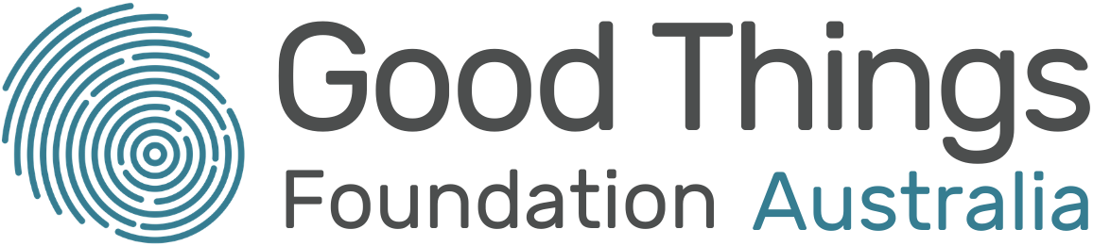
Dr Ellen Skladzien
CEO, Down Syndrome Australia
E: Ellen.skladzien@downsyndrome.org.au
www.downsyndrome.org.au
Down Syndrome Australia and its members acknowledge the Traditional Custodians of Country throughout Australia and their connections to land, sea, and community. We pay our respect to their elders past and present and extend that respect to all Aboriginal and Torres Strait Islander peoples today.

